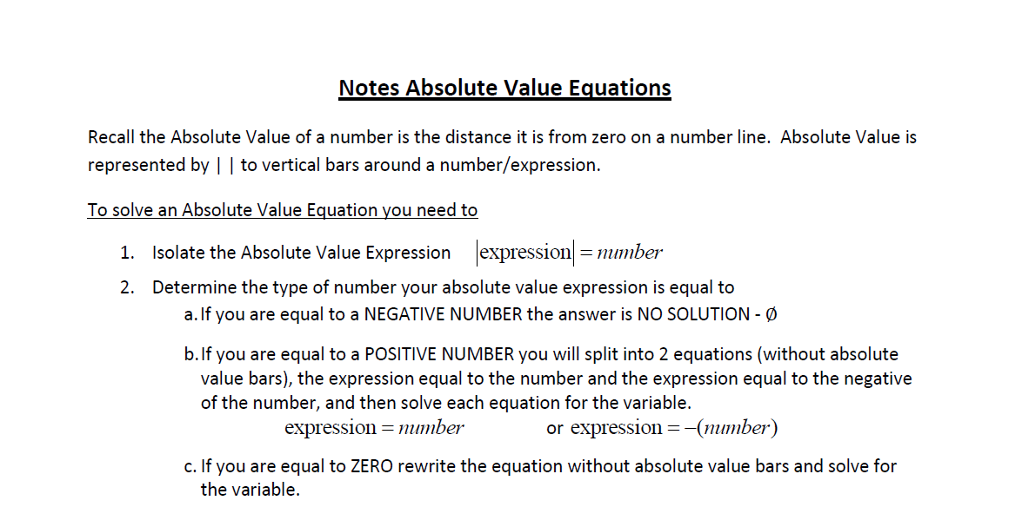Math 4 Name ______________________________

**1-1 Extension Absolute Value Function Review**Date________

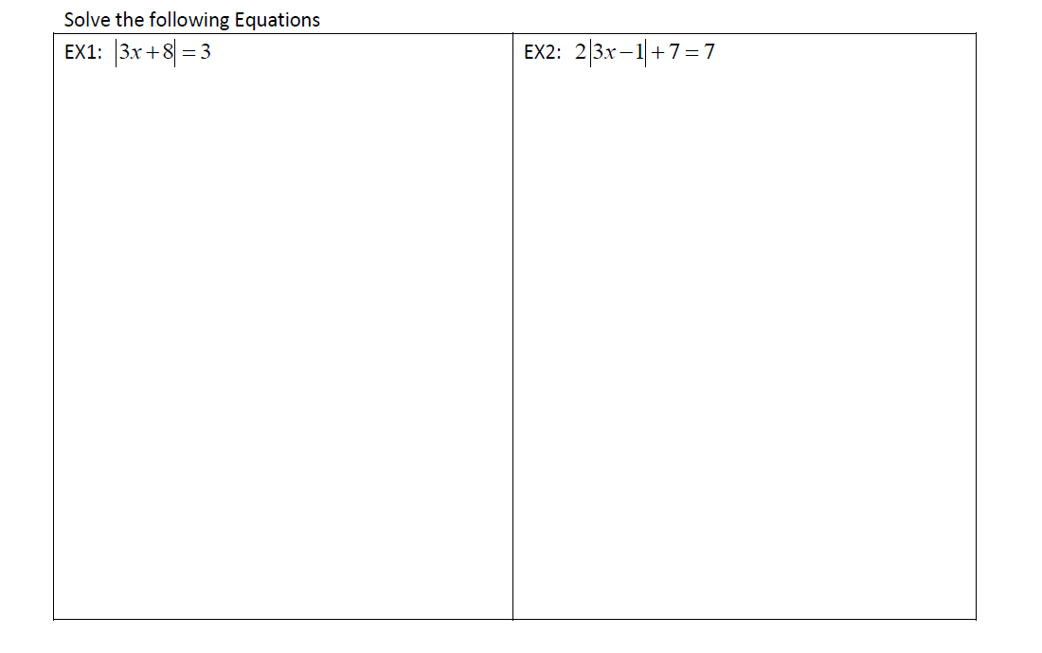

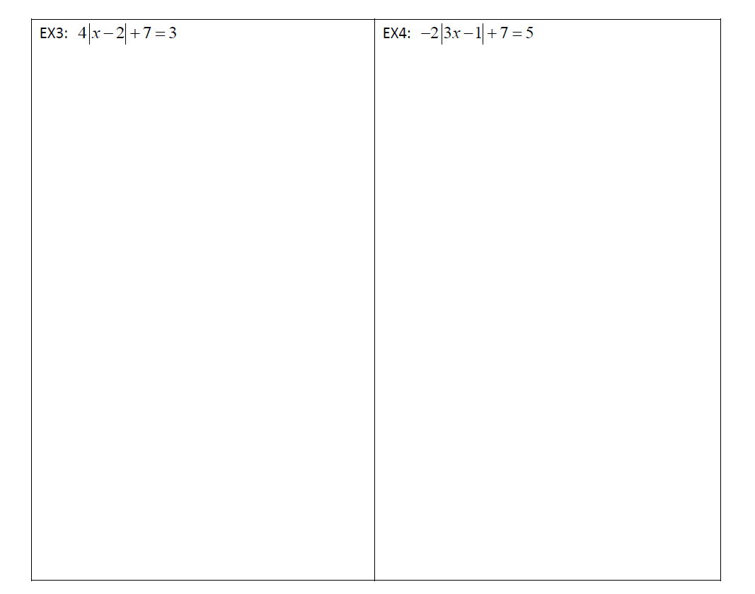

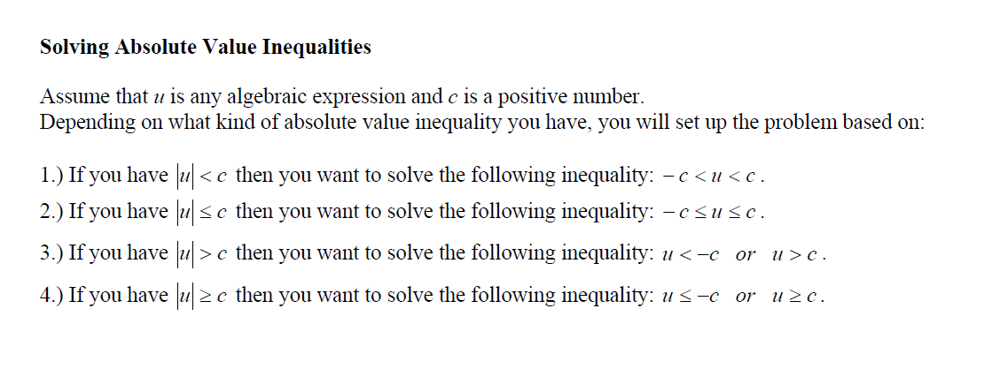

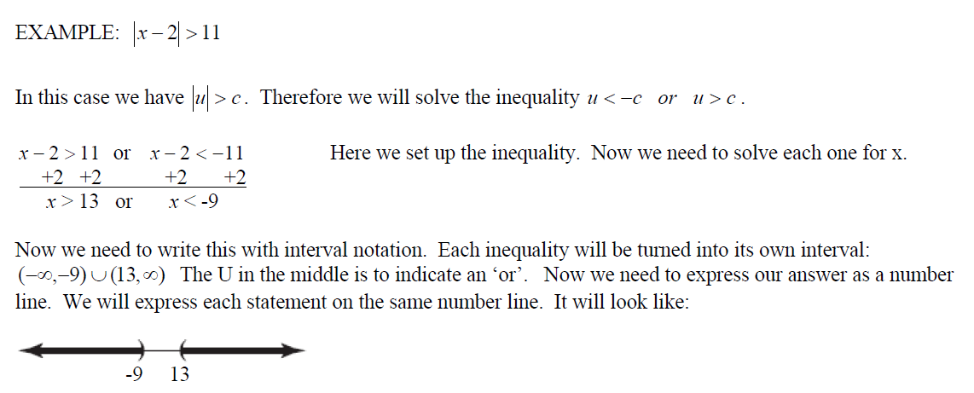

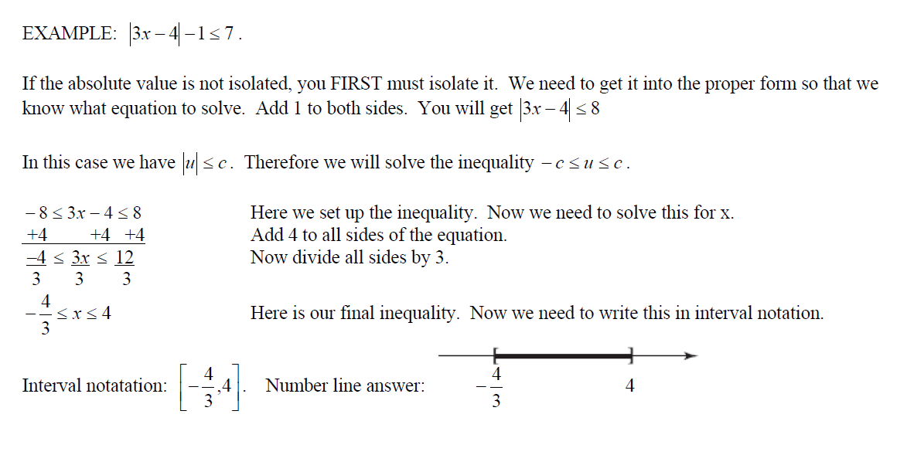

Summary:

If then *x = n* or *x = -n*.

If then 

If then  or 

**Solve each equation/inequality**

**1.  2. **

**3.  4. **

**5.  6. **

**7.**  **8.** 

>

> $≤$

**9.**  **10.** 

>

**11.**  **12.** 