Math 3 Name:

* 1. Graph and Table Practice

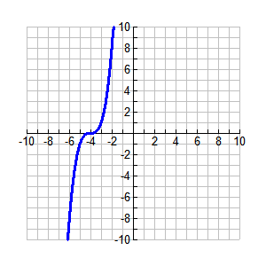Directions: If the graphed function has an inverse, graph it on the same graph.

1.

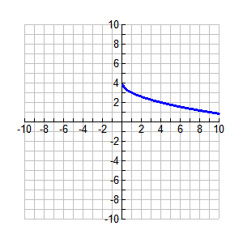

2.

3. 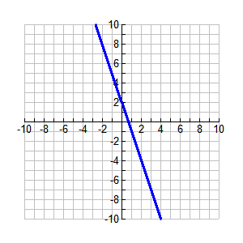

4. Use the table below for t(x) to evaluate the following expressions. Show all work!

|  |  |  |  |  |  |  |  |
| --- | --- | --- | --- | --- | --- | --- | --- |
| x | -3 | -2 | -1 | 0 | 1 | 2 | 3 |
| t(x) | -4 | -3 | -2 | -1 | 0 | 1 | 2 |

1. 
2. 
3. 