Math 3 Name_______________________________

1-1 *Inverse Function* Homework 2

* *I can demonstrate conditions that guarantee existence of an inverse function for a given function*
* *I can develop and use strategies for recognizing invertible functions from tables and graphs*
* *I can develop and use strategies for finding rules of inverse functions*

1. For each of the below graphs, decide if the given function has an inverse. Explain why or why not.

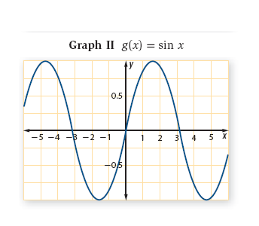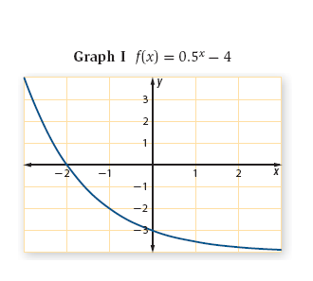

**MULTIPLE CHOICE. Select the letter that is the inverse of the below functions:**

1.  2. 

a.)  a.) 

b.)  b.) 

c.)  c.) 

d.)  d.) 

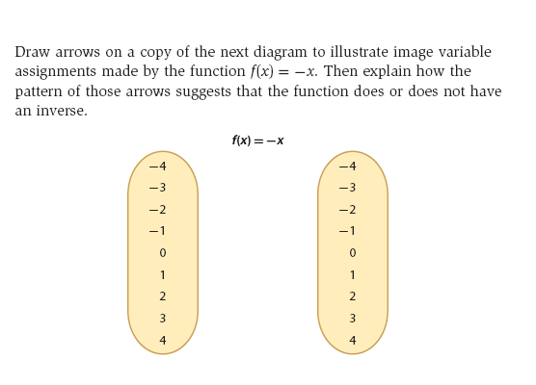3.

If the function has an inverse, find it.

4. Find rules for inverses of the following functions. Make sure to write your final answer in function notation.

a. b.

c. d.

5. Given the below table of values for the function , find .

|  |  |  |  |  |  |
| --- | --- | --- | --- | --- | --- |
|  | 1 | 2 | 3 | 4 | 5 |
|  | 6 | 3 | 2 | 5 | 8 |