Math 3 Name_______________________________

1-1 *Inverse Functions*

* *I can identify and find the inverse of a function algebraically and graphically.*
* *I can determine if a function is a one-to-one function.*

[](http://www.google.com/url?sa=i&rct=j&q=&esrc=s&source=images&cd=&cad=rja&uact=8&ved=0ahUKEwj8ssSGg7XOAhUHxiYKHREfD58QjRwIBw&url=http://www.pokego.org/pokedex/dratini/&psig=AFQjCNE_NnP-qt3efHWJs_Nw99fNRkk0Vg&ust=1470855720179811)[](http://www.google.com/url?sa=i&rct=j&q=&esrc=s&source=images&cd=&cad=rja&uact=8&ved=0ahUKEwiB0tujg7XOAhVMSSYKHZpgDD0QjRwIBw&url=http://www.pokemongo.com/&psig=AFQjCNGUc6RZSlU_QMeE0SkTCNLggIDIYQ&ust=1470855878264174)Have you ever heard the expression “she knows it forward and backward” to describe someone who fully grasps a concept? Often, being able to reverse a process is a way to show how thoroughly you understand it. In this lesson, you will reverse mathematical processes, including functions. As you work on this lesson, keep these questions in mind:

* *How can I “undo” each step?*
* *How can I justify each step?*

**Introduction**

Suppose you just captured Dratini (pictured above), a very rare Pokémon in the game Pokémon Go. After catching him, your phone dies and you need to return home to charge it. Unfortunately, you won’t be able to use your phone to get home but you do remember how you got to this ‘magical’ place where you captured Dratini.

* You left your house and went East on Mayfield Road and drove for 45 miles
* Then you turned right onto Orchard Street
* You then turned left onto Avon Drive
* Then you passed 5 houses and turned right into some creepy parking lot to catch Dratini.

1. Write down your directions to get home below. It may be helpful to draw a picture.







1. How could you come up with the directions to get home without drawing a map or using a phone?
2. Suppose your friend picked a number and performed the following algorithm:

* Start with any number, add 5 to it.
* Divide the result by 3.
* Subtract 4 from that quantity.
* Double your result.

Your friend ended up with 10 after performing all 4 steps above. Working backwards knowing the end result is 10, find the original number your friend started with. Show your work.

1. Write a function that works for your friend’s algorithm mentioned above in #3 for any original number *x* to arrive at a final result. Check to make sure your equation works.



1. Write a function that ‘undoes’ or reverses your friend’s algorithm for a final result *x* to arrive back at the original number. Check to make sure your equation works and undoes (or reverses) the algorithm from #3.



1. Complete the table below using your two equations that you just wrote from #4 and #5

|  |  |  |  |
| --- | --- | --- | --- |
|  |  |  | Does  undo  to return |
| 22 |  |  |  |
| 1 |  |  |  |
| 7 |  |  |  |
| -8 |  |  |  |

1. Complete the table below for your two equations that you just wrote from #4 and #5

|  |  |  |  |
| --- | --- | --- | --- |
|  |  |  | Does  undo  to return |
| -2 |  |  |  |
| 4 |  |  |  |
| -6 |  |  |  |
| -12 |  |  |  |

1. When you input a number into either function and plug the result into the other function, you return your original number. and  are functions that _________ each other. Functions that do this are called **inverse functions**.
2. Mathematicians refer to the inverse of  as .

 is read as “ inverse of x”

Using your equations from above for  and  write the inverse of both functions using the correct function notation. You should write an equation for the inverse of  and another equation for the inverse of .

1. 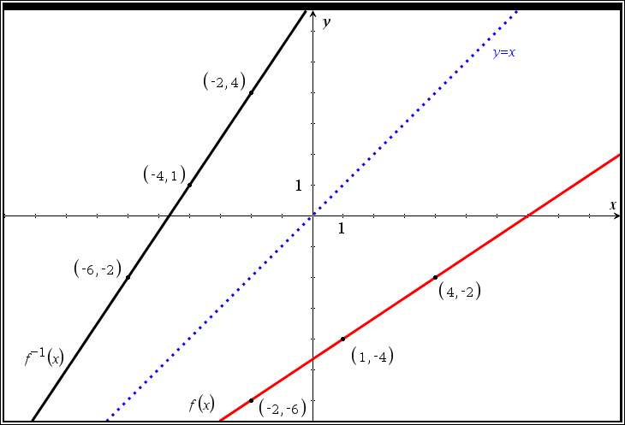Carefully examine the graph to the right of  from #4 and its inverse .
2. Geometrically what do you notice about the graph of  and  with respect to the dashed line ?
3. Notice that  which means the point ( _____, _____ ) is on the graph of . Since  must undo , it takes the output of -6 and uses it as the input.

Since , the point ( ____, ____ ) must be on the graph of 

1. If , then the point ( ____, ____ ) must be on the graph of .

Assuming that inverse existed, what point would have to be on 

1. If  is on the graph of , ( ____ , ____ ) would be on the graph of .

**How to find an inverse of a function algebraically.**

***Notes*** Example:  find 

1. Find the inverse function of each of the below functions algebraically, then complete the table and use it to graph both the function and the inverse on the given coordinate plane.

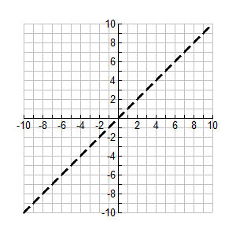

a. 



|  |  |  |  |  |  |
| --- | --- | --- | --- | --- | --- |
|  | -4 | -2 | 0 | 2 | 4 |
|  |  |  |  |  |  |



b. 



|  |  |  |  |  |  |
| --- | --- | --- | --- | --- | --- |
|  | -2 | -1 | 0 | 1 | 2 |
|  |  |  |  |  |  |

1. 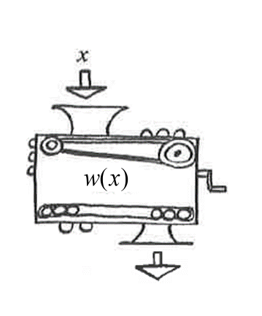Use the table below for the function to answer the following questions.

|  |  |  |  |  |  |
| --- | --- | --- | --- | --- | --- |
|  | -2 | -1 | 0 | 1 | 2 |
|  | -1 | 0 | 1 | 2 | 3 |

1. ** b. **
2. ** d. **
3. Find the inverse for the following functions:
4.  b. 

c.  d. 

1. Remember, a function is a mathematical relation in which every input value (represented by *x*) is paired with exactly one output value (represented by *y*). In more technical terms, every value in the domain is paired with exactly one value in the range.

Below is an arrow drawing representing the assignment of inputs to outputs for the function .

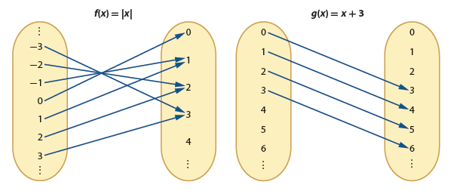

1. Explain how you know is a function.
2. Explain why  does not exist.

**Notes**

The existence of inverses

1. Decide if the inverse of the below graphs exists. Explain your reasoning.

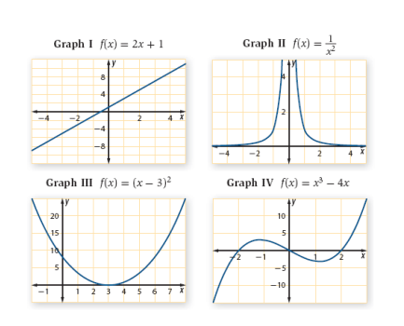

|  |  |  |
| --- | --- | --- |
| **Graph** | **Inverse (Yes/No)** | **Reasoning** |
| I |  |  |
| II |  |  |
| III |  |  |
| IV |  |  |

1. Solve the following equation: 
2. Think about the graph of. Would  exist?

If not, is there something we could do to  to allow  to exist?

**Notes**

Restricted domains

1. Given the following table of values for the function, give the domain and range, then create a table of values for  and give the domain and range.

|  |  |  |  |  |  |  |  |  |  |
| --- | --- | --- | --- | --- | --- | --- | --- | --- | --- |
| ***x*** | *-4* | *-3* | *-2* | *-1* | *0* | *1* | *2* | *3* | *4* |
|  | *2* | *1* | *0* | *-1* | *-2* | *-3* | *-4* | *-5* | *-6* |

**Domain:**

**Range:**

|  |  |  |  |  |  |  |  |  |  |
| --- | --- | --- | --- | --- | --- | --- | --- | --- | --- |
| ***x*** |  |  |  |  |  |  |  |  |  |
|  |  |  |  |  |  |  |  |  |  |

**Domain:**

**Range:**

1. Create a table of values for a function *g* that does NOT have an inverse then explain why the inverse could not exist.
2. 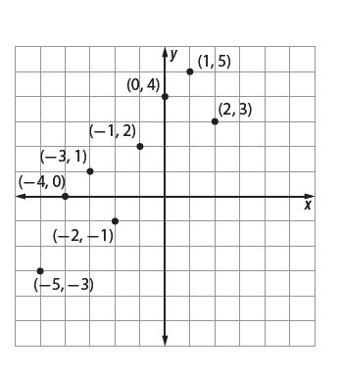Suppose that the coordinates of the function *g(x)* are shown on the graph below. Plot points that represent coordinates for $g^{-1}\left(x\right)$.

.

**SUMMARY:**

What patterns in an arrow diagram of a function indicate that the function does or does not have an inverse?

What patterns in the graph of a single coordinate graph indicate that the function does or does not have an inverse?

What geometric pattern relates graphs of functions and their inverses? How does this play into the coordinates of points on the function and the inverse?

What strategies do you use to algebraically find  when you know the equation for?