Math 3 Name:

* 1. The Function Machine

1. Using the table below for f(x) and thinking about a function machine, determine the following:

|  |  |  |  |  |  |  |  |
| --- | --- | --- | --- | --- | --- | --- | --- |
| x | -2 | -1 | 0 | 1 | 2 | 3 | 4 |
| f(x) | -1 | 0 | 1 | 2 | 3 | 4 | 5 |

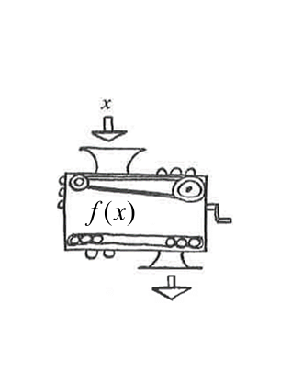

1. 



1. Find x when 
2. 
3. =