Math 3 Name: ___________________________

1-2 Additional Practice



Formulas: 

1. How do you know which equation to use when working with compound interest scenarios?
2. 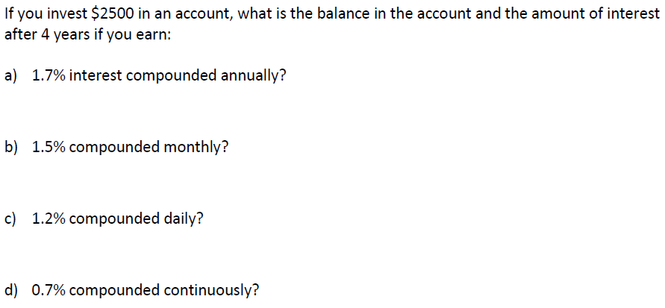

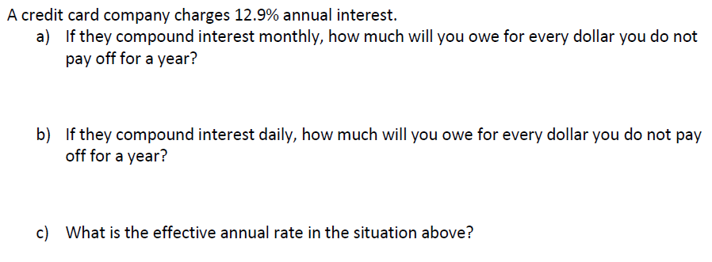



(In other words, find the APY)

1. 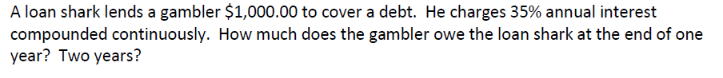
2. Your allowance of $190 earns 11% compounded monthly for  years. What’s it worth after  years?
3. Your 3 year investment of $20,000 received 5.2% interested compounded semi annually.
4. What is your total return?
5. If your interest had been compounded continuously, how much more would you have made?