Math 4 Name_______________________________

**1-2 Composition of Functions** Date________

* *I can use the definitions and important properties of arithmetic operations, including function composition, in order to combine functions.*

1. Use the function  to evaluate  Explain what that tells you about the graph of *f*(*x*).
2. Suppose  represents the height (in feet) of a baseball *t* seconds after it is hit. Explain what  tells us about the situation.
3. If recall that 

Find the solutions to the problems below.

a. $\left[f+g\right]\left(-2\right)=$ b. $\left[f+g\right]\left(x\right)=$

c. $\left[f-g\right]\left(5\right)=$ d. $\left[f-g\right]\left(x\right)=$

e. $\left[f∙g\right]\left(-4\right)=$ f. $\left[f∙g\right]\left(x\right)=$

g. $\left[f÷g\right]\left(7\right)=$ h. $\left[f÷g\right]\left(x\right)=$

1. Use the information below to help answer the questions.

* The annual net income from lottery operation (in millions of dollars) depends on the state’s adult population *p* (in millions) according to the function: 
* The state’s adult population *t* years from now is predicted by the function: 

1. Explain what you would have to do to find the net income from lottery operation in 5 years.
2. Find the net income from lottery operation in 5 years.
3. Write a single algebraic rule that can be used to calculate the annual net income from lottery operation *t* years in the future. In other words, express net income as a function of *t*.

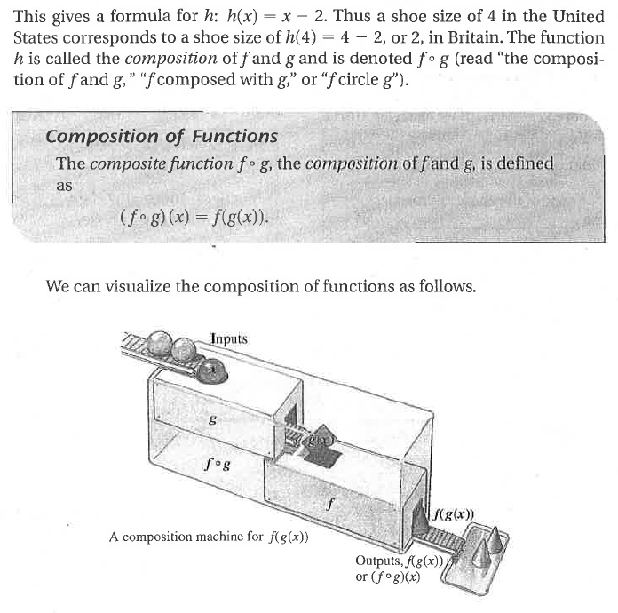

Your answer to 4c involved combining two functions by an operation called composition. The **composition of functions** is defined as  and involves using the output of one function as the input of the other. This is illustrated to the right.

**Example**: If the rule for the composite is  To find a specific solution is simple: 

**Practice Problems**

5. 

a. Find 

b. Find 

c. Find

6. 

a. Find 

b. Find 

c. Find 

7. 

a. Find 

b. Find 

c. Find 

8. 

a. Find 

b. Find 

c. Find 

9. 

a. Find 

b. Find 

c. Find 

10. Compare all of the Part b and c answers to Questions 5-9. How is 9 different from the rest?

1. What vocabulary word from last year describes the relationship between
2. Find another pair of functions that have the same relationship.

11. Find two functions andthat compose to give , where and 

12. Find two functions andthat compose to give, where and 