Math 3 Name_____________________________________

1-2 *Compound Interest and the Number e*

* I can solve problems involving compound interest, including continuous compounding

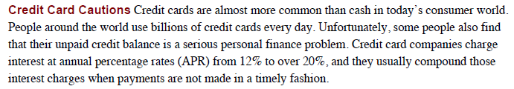

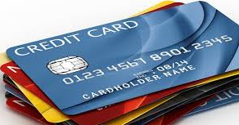

One day soon you will be signing up for your own credit card. Suppose when you get the credit card in the mail you are so excited that you carelessly run up a $1,000 bill the first month.

Suppose your credit card charges you an **annual percentage rate** (**APR**) of 18% and the interest is **compounded** monthly. This means interest is charged every month and your balance (the total amount of money you must pay back to the credit card company) increases.

The equation below will allow you to calculate how much money you would have to pay back to the credit card company after *t* years go by with you making no payments.

Note: While not making payments is highly unlikely because all credit card companies require consumers to make a minimum monthly payment, it is an extremely useful scenario for consumers to think about so they can compare credit cards to find the best option available.



|  |  |
| --- | --- |
| **Compounded** | **n value** |
| Daily | 365 |
| Weekly | 52 |
| Monthly | 12 |
| Quarterly | 4 |
| Semi-annually | 2 |
| Annually | 1 |

Note:

*t* = time gone by measured in years

*A(t) =*  the amount of money you owe after *t* years pass

*P =* Principal amount (how much money you originally

charged on your credit card)

*r =* the annual percentage rate (as a decimal)

*n* = how many times the interest will be compounded in 1 year.

1. Find the balance on the credit card mentioned above after the times given below.

Write down the equation and then use your calculator to determine the balance.

a. 6 months? b. 1 year?

2. Compare the credit card balance at the end of one year to the starting balance. What is the percentage increase in the amount you owe? (*The first step to finding the percentage increase is to divide the balance at the end of twelve months by the original balance*. This will give you a percent written as a decimal. To turn the decimal into a percent multiply by 100. Now subtract 100 to see what percent your balance increased by over 1 year)

The percentage you found in problem 2 is called the **Annual Percentage Yield** (**APY**)

3. Suppose another bank offers a different credit card, also with an 18% APR, but compounded quarterly (every three months). Calculate the balance of the credit card at the times below. Show your work.

3a. After 3 months? 3b. After 6 months? 3c. After 1 year?

4. Which credit card is better for you as the consumer? Prove your answer by calculating the APY for the credit card from problem (3).

5. If you have $3,000 to invest in a bank account, which account should you choose? Show work and/or explain your answer.

a. Bank A: 10% interest rate, compounded yearly

Bank B: 9.62% interest rate, compounded monthly

Bank C: 9.6% interest rate, compounded daily

Situations involving *continuous* compounding can be modeled by the formula, where *r*  is the interest rate as a decimal (and can be negative for exponential decay) and *t* is time in years.

6. The population of the world is increasing at approximately 1% per year, compounded continuously. According to [www.census.gov](http://www.census.gov), the population of the United States (as of 11:12am on May 6, 2014) is approximately 317,998,962. What will be the approximately population of the United States on May 6, 2020?

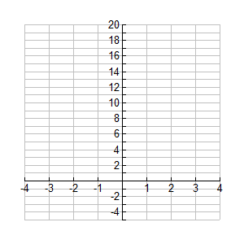

7a. Sketch a graph of  using your calculator.

7b. To which function family does belong?

7c. Describe the rate of change of ?

7d. What is the domain and range of ?