Math 3 Name: _________________________
1-3 Common Base Practice

Work these out on a separate piece of paper! No Calculator
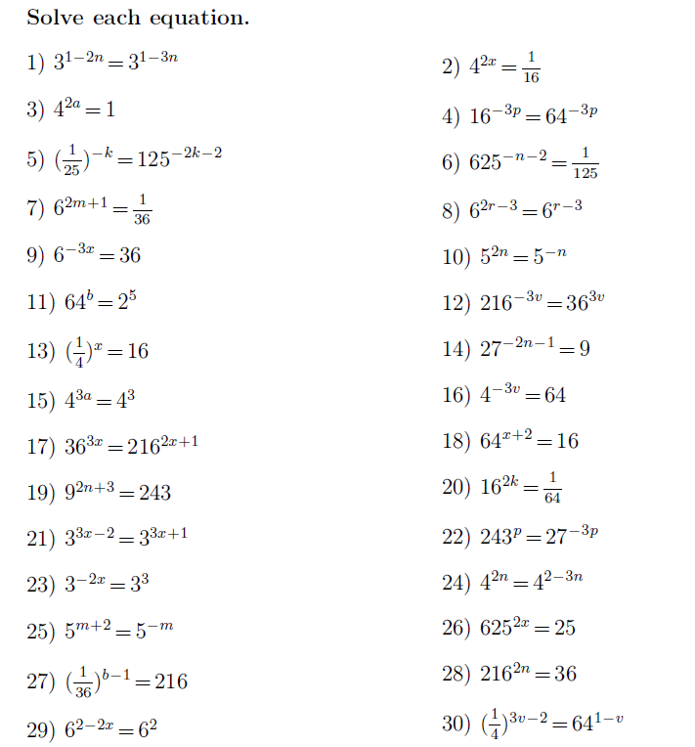

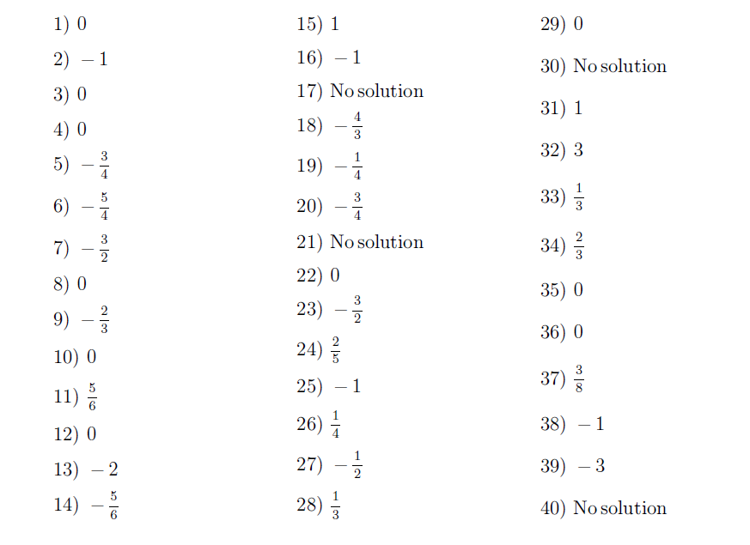
Answers

