Math 3 Name__________________________________ 1-3 *Introduction to Logarithms*

* I can recognize what is meant by “taking the logarithm” of a real number.
* I understand the connection between logarithmic functions and exponential functions and can use this understanding to solve problems.

In Math 1, we studied exponential functions (in the form y = *ab*x). Today, we are going to look at a related function, the logarithm.

1. Fill in the table below using the function **

|  |  |  |  |  |  |  |  |
| --- | --- | --- | --- | --- | --- | --- | --- |
| **x** | -2 | -1 | 0 | 1 | 2 | 3 | 4 |
| ***f*(x)** |  |  |  |  |  |  |  |

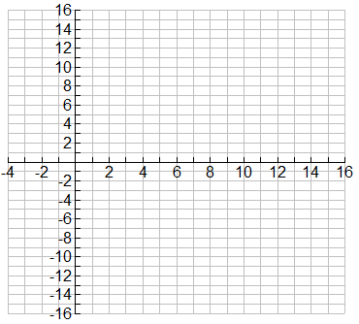

2. Make a scatterplot of the above data on the below axes.

3. Graph the line on the below axes.

4. Graph  on the same set of axes. That is, graph the **inverse** of y = 2x (*hint: use the table!!*)

The inverse of an exponential function (that has a graph like the one seen above in number 4 is called a **logarithm** (log for short).

Therefore, the inverse of  is 

5.  is an exponential expression. What do you think would happen if we took the log base 5 of ?

6. Use your calculator to evaluate .

7. Evaluate the following expressions below. Use your calculator when possible.

1.  b.  c. 

d.  e.  f. 

g.  h.  i. 

j.  k.  l. 

We will use this concept of inverses later to help us isolate variables when we are solving exponential and logarithmic equations.

Since log base m and exponential base m are inverses of each other, we can apply the inverse to both sides of an equation to help us isolate the variable.

Much like we can take the square root of both sides of an equation, or add 2 to both sides of an equation, we can also take a log of both sides of an equation or write both sides of an equation as an exponent of some desired base. We will use this concept of inverses below.

8. Use inverses to solve the below problems.

a.) log10 *a* = 4 b.) log4 *c* = 3 c.) log15 *d* = 1 d.) log6 *g* = 0

9. Log10 is called the **common log** and is used so much that it is built into your calculator. Whenever you see simply “log *x*” in a problem, it means “log10 x”. The logarithm function is built into your calculator. Use your calculator to find log 150. What does this tell you (use exponential notation)?

***Notes: ***

* The above equation is read as:
* x (what you are taking the log of) must be __________ but not equal to _____.
* This means the domain of any logarithmic function is:
* b (the base of the log) must be positive also.
* The output of a logarithmic function (y) can be _________________________

**Solve for *x* in the following equations using the definition of a logarithm. NO CALCULATORS!!**

10.  11. 

12.  13. 

14.  15. 

16.  17. 

18.  19. 

**Applications of Logarithms**

Have you ever had someone tell you that you were speaking too loudly (or too softly) or that the volume on the TV was turned up too high (or down too low)? While sensitivity to noise can vary from person to person, in general people can hear sounds over an incredible range of loudness.

Sound intensity is measured in physical units of watts per square centimeter. But the *loudness* is typically reported in units called decibels. The next table shows intensity values for a variety of familiar sounds and the related number of decibels – as measured at normal distances from the sources.

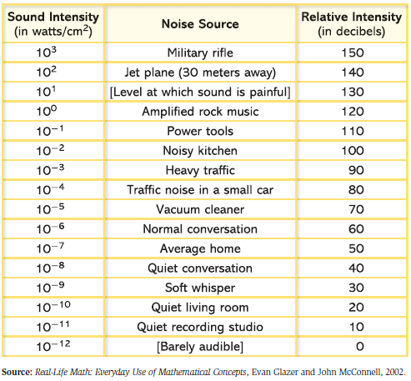

The **algorithm** (step by step procedure) used for converting watts per square centimeter to decibels is below:

If the intensity of a sound is ,

then its loudness in decibels is 

The key to discovery of this conversion rule is the fact that all sound intensities were written as powers of 10. However, if the sound intensities were numbers such as, the conversion would not be so simple. You would need to write the numbers as powers of 10. Let’s explore how we can write *any numbers* as a power of 10.

20. Express each of the numbers in Parts a-i as accurately as possible as a power of 10. You can find exact values for some of the required exponents by thinking about the meanings of positive and negative exponents. Others might require utilizing a calculator and what you just learned on the first page of this packet.





21. Suppose that the sound intensity of a screaming baby was measured as . To calculate the equivalent intensity in decibels, 9.5 must be written as for some value of *x*.

a. Between which two integers does it make sense to look for values of *x*? Explain.

b. Use a logarithm to find the value of *x*.

c. What is the decibel level of the baby’s cry? Where does the decibel level rank in terms of the list on the previous page?

d. If a second baby is crying at 115 decibels, what is the sound intensity (in ) of the baby’s cry?

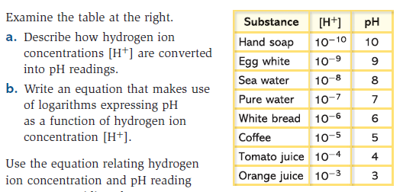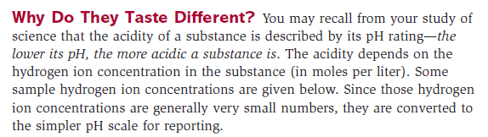

22. Examine the table at the right. Note that if the concentration of  is written in the form , then the pH level is 

1. Write an equation that makes use of logarithms expressing pH as a function of hydrogen ion concentration . **Check your answer with Mr. Grano before moving on to number 23!**



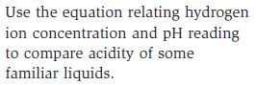

23.

