Math 4Name ______________________________

**1-3 Parametric Equations** Date _______

Learning Goals:

* *I can write and graph parametric equations.*
* *I can solve applications involving parametric equations.*

**Parametric equations** for a curve are equations in which the *x* and *y* coordinates are both expressed in terms of a single variable, called the parameter, *t.* In “real-life” applications, *t* often represents time.

I. Consider the following scenario:

*A puppy weighs 8 pounds and is 15 inches long at birth. For its first year of life, each month the puppy grows .5 inches and gains 3 pounds.*  Complete the following table:

|  |  |  |  |  |  |  |  |  |  |  |  |  |  |  |
| --- | --- | --- | --- | --- | --- | --- | --- | --- | --- | --- | --- | --- | --- | --- |
| **Time (months)** | **0** | **1** | **2** | **3** | **4** | **5** | **6** | **7** | **8** | **9** | **10** | **11** | **12** | **Rules:** |
| **Height (in.)** |  |  |  |  |  |  |  |  |  |  |  |  |  | *x*(*t*) = |
| **Weight (lbs.)** |  |  |  |  |  |  |  |  |  |  |  |  |  | *y*(*t*) = |

1. Sketch the following graphs:

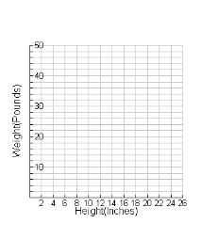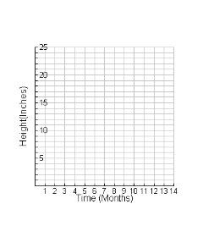 *Time vs. Height Time vs. Weight Height vs. Weight*

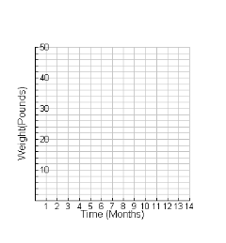



Parametric equations for this scenario:

1. See if you can reproduce your *Height vs. Weight* graph on your calculator. Follow these tips . . . .

**Take notes below on how to graph parametric equations (Menu-3-3):**

Some things to consider . . . .

Adjust your *window*. Use graph #3’s axes as a guide.

What will you enter for *t* minimum and maximum values?

What about your *tstep*?

Not sure?

Just experiment . . . .

1. Both parametric equations can be combined into one rectangular equation (in terms of *x* & *y* only.)

This is called **eliminating the parameter, *t.*** To do this, start by solving the *x-*equation for *t.* Substitute the expression for *t* into the *y-*equation & simplify. *Show your work below.* Test your new rectangular equation by graphing it.

II. Applications:

1. Parametric equations enable us to graph a curve that may double back on itself or cross itself. Such a curve cannot be described by a function *y* = *f*(*x*). The following examples are curves that are not functions in the rectangular system.
2. Graph the curved defined by the following set of equations



over the interval  with *tstep* = 1in your calculator. Make a sketch of the graph.

**Window:**

Xmin: -5

Xmax: 20

Ymin: -8

Ymax: 20

1. Make sure your calculator is in radians. Graph the curve defined by *x*(*t*) = 3cos *t*

the set of equations to the right over the interval  *y*(*t*) = 3sin *t*

Use a *tstep* of π/6. Make a sketch of the graph.

What equations would yield the *unit circle*? What *tstep* would you use?

1. Here is another interesting example. Change the *tmax* to 12 π then graph. Adjust the window so you can see the full curve.



B. Eliminating the Parameter



Sketch the curve represented by the parametric equations on interval  

Copy the sketch below.

It looks very similar to another graph in rectangular form. To find that equation, do the following.

i. In one of the equations, solve for *t*. You decide which one looks easier.

ii. Substitute that value for *t* into the other equation and solve.

**Practice:** Sketch the curve represented by the equations below by eliminating the parameter and adjusting the domain of the resulting rectangular equation.



Math 4 Name_______________________________

**1-3 Parametric Equations Practice** Date________

1. Make a table of values for the curve defined by the following

set of equations over the interval  

Sketch a graph of the curve.

Write the parametric equations below as a single equation in *x* and *y* by eliminating the parameter, *t*. Check your result by showing that its graph and the graph of the parametric equations are the same.

2.  3. 