Math 3 Name ______________________________  
1-3 Practice **No calc unless problem denoted with \***

1. Graph the function  Use window: *x:* 

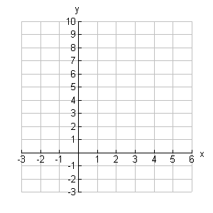

1. State the **domain** of *f* .

b. State the **range** of *f .*

1. Find 
2. Graph  above on the same axes as .
3. State the **domain** of 
4. State the **range** of 
5. Sketch the line  on the graph above.
6. Use what you have learned about logarithms to solve for x in the following equations:

*a.  b. 

c.  d. 

e.  *f. 

g.  *h. 

*i.  j. 

6. *a.  b. 

c.  d. 

e.  f. 

g.  *h. 