Math 3 Name ____________________________  
1-4 Solving Exponential Equations (Using Logs)

* *I can solve for exponents using logarithms.*

Video - <https://www.youtube.com/watch?v=UFgod5tmLYY>

*e* is approximately ___________________________________

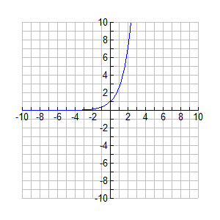Graph of  ln stands for _______________________

and means log base ____

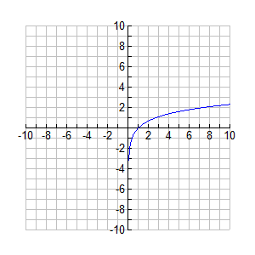Graph of :

*Domain:*

*Range:*

*Y-intercept: Domain:*

*Horizontal Asymptote: Range:*

Find : X-intercept:

*Vertical Asymptote:*

Since logarithms isolate the exponent, logarithms are used to solve exponential equations.

**REVIEW:**

***Remember, the definition of a logarithm states:***

$b^{a}=c$**if and only if**

1. Without the use of a calculator, evaluate the below expressions. Show your work/explain your answers.

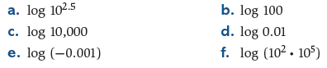

**2.** Without using a calculator, find the consecutive integers just below and just above the exact value of the given logarithms.



c.  d. 

**3.** Solve the following equations using the definition of logarithms. You may need to use other solving techniques before you use the logarithm.

a.  b.  c. 

d. 

4. Suppose that the number of bacteria in a lab dish at any time *t* hours after the start of an experiment is given by the function . Show how to use logarithms to find the time when there will be 10,000 bacteria in the lab dish.

5. You invest $5,000 in an account that earns 3% interest compounded daily. How long (exactly) until the account reaches $20,000?

6. A certain radioactive material decays at a rate that is modeled by the equation, where *t* is measured in years. What is the half-life of this radioactive material? That is, how long (exactly) will it take for the material to decay to half of its original amount?