Math 3 Name_______________________________

1-5 Practice 3 **No Calculator unless problem is denoted with \***

Solve the below exponential equations.

6*. 7.

8*. 9.

10. 11.

12. **CHALLENGE: $\frac{4^{2x}}{2^{x-3}}=1$**

Solve the following word problems. Use the equation , where:

* is the initial amount
* *r* is the rate of growth (positive) or decay (negative) *as a decimal* (NOT a percentage)
* *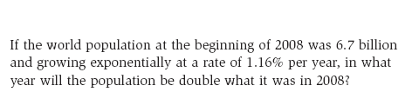t* is the unit time in the given problem

14*.

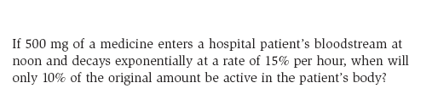

15*.

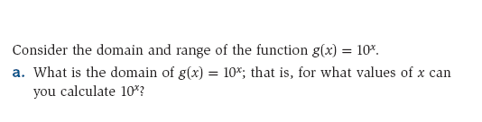**Domain and Range of Logarithmic Functions**

16*.

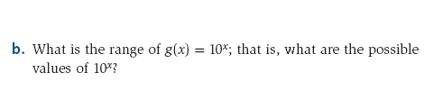

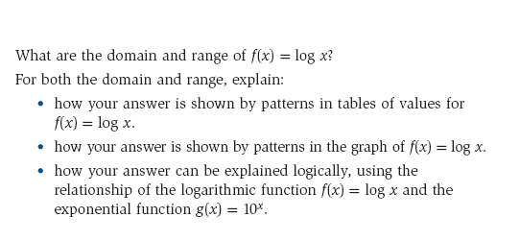

17*.