Math 3 Name_________________________

1-5 Homework

**In 1-9, solve for *x*using properties of logarithms. NO CALCULATOR!!**

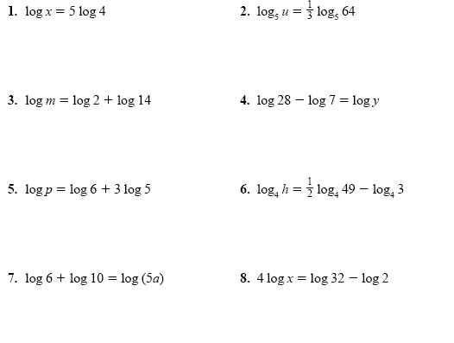

9.  10. 

**In numbers 11-18, simplify the given expression as much as possible. Leave all answers as fractions. NO CALCULATOR! (except #16)**

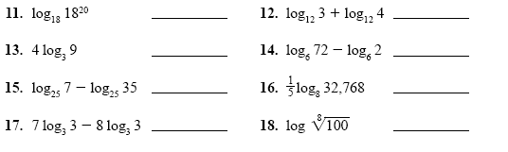

19. Write an expression for *x* without using logs: log *x* = 5 log *y* – 3 log *z* + 4 log *w*

20. Write as a single logarithm: log 85 – log 17 + .5log 400

(*you may divide* ***once*** *on your calculator)*

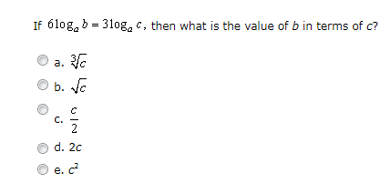21. From the SAT II Math subject test: