Math 4Name ______________________________

**1-5 Solving Inequalities (NLA)Date________**

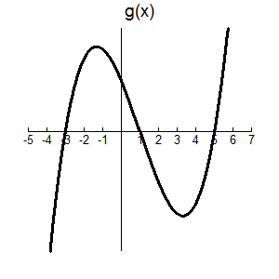

I. Consider the function *g(x)* graphed at the right.

What does it mean to say …

“Where does the function equal zero?”

“Where is the function positive?”

How can you look at the graph of a function and

determine where a function is positive or negative?

II. Graph the function $f\left(x\right)=x^{2}-3x-18$ and determine where *f(x)* > 0.

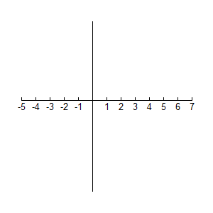

III. How could you determine where a function is positive of negative without the aid of a graphing calculator? **Number Line Analysis!!**

Example: Solve $x^{2}+3x-4<0.$ (this means negative!)

Solution: **1.** Factor completely. $x^{2}+3x-4=(x-1)(x+4)$

**2.** Create a number line putting the zeros of each of the factors on the number line.

-4

1

**3.** Divide the number line into regions using the zeros.

-4

1

**4.** Place the factors along the side.

*x* – 1

-4

1

*x* + 4

**5.** Determine if the factors are positive or negative in each interval.

-4

1

*x* – 1 _ _ +

*x* + 4 _ + +

**6.** Multiply down the columns to determine the final sign in each interval.

-4

1

*x* – 1 _ _ +

*x* + 4 _ + +

+ _ +

**7.** Answer the question! We were trying to determine where $x^{2}+3x-4<0$. Looking at the above number line we see that happens between *x* = -4 and *x* = 1. This is written (-4, 1) or using inequalities as -4 < *x* < 1.