Math 4 Name ______________________________
1-5 Solving Inequalities (NLA) Date________

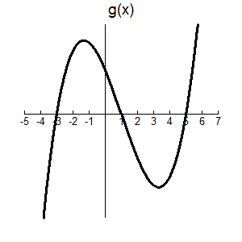
I. Consider the function g(x) graphed at the right.

What does it mean to say …

“Where does the function equal zero?”

“Where is the function positive?”

How can you look at the graph of a function and
determine where a function is positive or negative?

II. Graph the function $f\left(x\right)=x^{2}-3x-18$and determine where f(x) > 0.

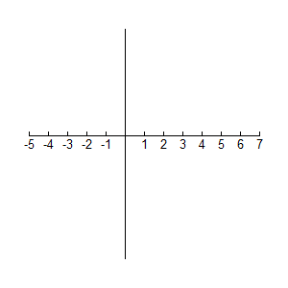

III. How could you determine where a function is positive of negative without the aid of a graphing calculator? Number Line Analysis!!

Example: Solve $x^{2}+3x-4<0.$ (this means negative!)

Solution: 1. Factor completely. $x^{2}+3x-4=(x-1)(x+4)$

2. Create a number line putting the zeros of each of the factors on the number line.

-4
1

3. Divide the number line into regions using the zeros.

-4
1

4. Place the factors along the side.

x – 1
-4
1

x + 4

5. Determine if the factors are positive or negative in each interval.

-4
1
x – 1 _ _ +

x + 4 _ + +

6. Multiply down the columns to determine the final sign in each interval.

-4
1
x – 1 _ _ +

x + 4 _ + +

+ _ +

7. Answer the question! We were trying to determine where $x^{2}+3x-4<0$. Looking at the above number line we see that happens between x = -4 and x = 1. This is written (-4, 1) or using inequalities as -4 < x < 1.

