Math 4 Name_______________________________

**1-6 Arithmetic and Geometric Sequences** Date________

*In this investigation, you will be working towards the following learning goals:*

*I can determine whether a sequence is arithmetic or geometric*

*I can find explicit or recursive formulas for the nth term of an arithmetic or geometric sequence*

*I can use sequences to solve problems*

I. **Notation for Sequences**

A sequence is an **ordered list of numbers**. The sequence is named with a letter and a subscript, for example . The letter is used to name the sequence, and the subscript (“*n*”) refers to the position of a number in the sequence. For instance, would refer to the 4th term in sequence *a*.

Given the sequence 

Find the following terms: ;; ;  ; 

II. **Formulas for Sequence**

Some sequences have formulas that generate them. Formulas can be either explicit or recursive. An **explicit formula** is a formula that allows direct computation of any term in the sequence. A **recursive formula** requires the computation of all previous terms in order to find the value of term 

Consider the sequence of positive even numbers 

The *explicit formula* for this sequence is 



The *recursive formula* for this sequence is or, equivalently

Note that for the recursive formula, you must know the first term, then you define the rest of the terms in relation to the first term.

Write out the first five terms of the following sequences:

 ­­______, ______, ______, ______, ______

 ______, ______, ______, ______, ______

 ______, ______, ______, ______, ______

 ______, ______, ______, ______, ______

III. **Arithmetic Sequences**

An ***arithmetic sequence*** is a sequence in which the difference between two consecutive terms is the same. The *common difference* is found by subtracting any term from its succeeding term. The *nth term* () of an arithmetic sequence with first term and the common difference is *d* is given by the following formula: 

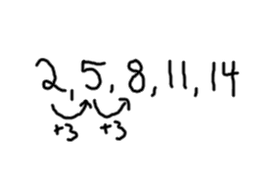

A. Name the first five terms of each **arithmetic sequence** defined below. An example is given.

**Example:**  🡪

1. 

2. 

3. 

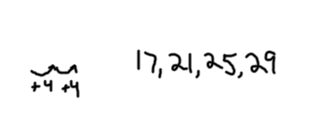

B. Name the next four terms of each of the following **arithmetic sequences**:

**Example:** 5, 9, 13

1. 21, 15, 9

2. 11, 14, 17

3. 9.9, 13.7, 17.5

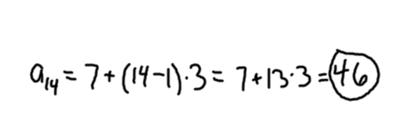C. Use  to find the *n*th term of the sequence (*n* is given)

**Example:** 

1. 

2. 

3. 

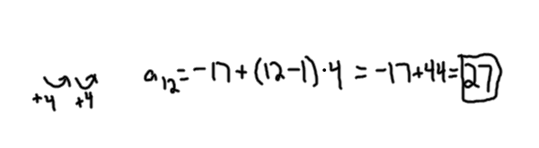

D. Find the indicated term in each **arithmetic sequence**:

**Example: ** for -17, -13, -9, . . .

1.  for 10, 7, 4

2.  for 8, 3, -2

3.  for 

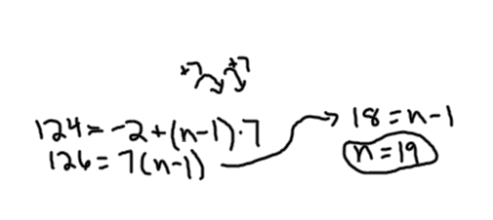E. Which term?

**Example:** Which term of -2, 5, 12, . . . is 124?

1. Which term of -3, 2, 7, . . . is 142?

2. Which term of 7, 2, -3, . . . is -28?

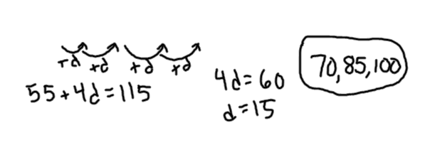F. Find the missing terms of the following arithmetic sequences:

**Example:** 55, ______, ______, ______, 115

1. -10, ______, ______, ______, ______, -4

2. 2, ______, ______, ______, ______, ______, 20

IV. **Geometric Sequences**

A ***geometric sequence*** is a sequence in which each term after the first is found by multiplying the previous term by a constant. In any geometric sequence, the *constant or common ratio* is found by dividing any term by the previous term. The nth term of a geometric sequence with first term and constant ratio *r* is given by the formula 

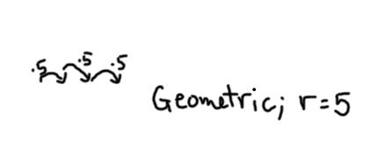

A. Determine which of the following sequences are geometric. If it is a geometric sequence, find the common ratio.

**Example:** 4, 20, 100, 500

1. 7, 14, 28, 56, . . .

1. 2, 4, 6, 8, . . .
2. 3, 9, 27, 54, . . .
3. 9, 6, 4, 

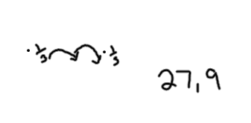

B. Find the next two terms for each **geometric sequence**:

**Example:** 729, 243, 81, . . .

1. 20, 30, 45, . . .

2. 90, 30, 10, . . .

1. 2, 6, 18, . . .

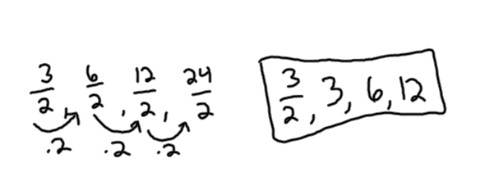C. Find the first four terms of each **geometric sequence** described below:

**Example:** 

1. 

2. 

3. 

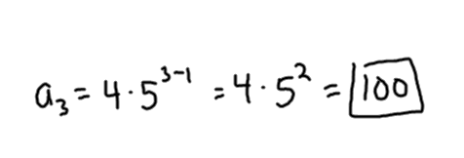D. Find the nth term of each **geometric sequence** described below:

**Example:** 

1. 

2. 

3. 

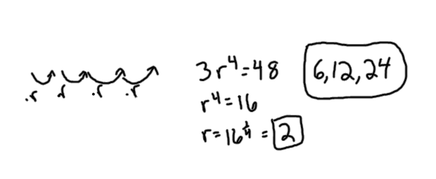

E. Find the missing terms of the following **geometric sequences**:

**Example:** 3, ______, ______, ______, 48

1. 243, ______, ______, ______, 3

F. Given the **geometric sequence** , which term in the sequence is 16777216?

V. **Finding Equations**

A. Find an explicit and recursive equation for the following sequences:

1. 

*Explicit Formula: Recursive Formula*

**

2. 

*Explicit Formula: Recursive Formula*

**

3. 

4. 