Math 3 Name ____________________________  
2-1 Equations of Circles

* *I can solve circle problems given an equation of a circle.*
* *I can write equations for desired circles.*

In Math 2, you attained awesomeness after learning about circles in the coordinate plane.

1. On your calculator,create a new document and open a Graphs page.

Press Menu, then select Graph Entry/Edit, Equation Template, and Circle.

Graph the following equation:  and then determine the following:

1. The center of the circle is located at _________________.
2. The radius of the circle is _______.
3. A curve is **tangent** to a line if it touches the line at one and only one point. The single point where the curve and the line touch is called **the point of tangency**.

Our circle is tangent to the ______________ which has an equation of _____________ at the point __________.

1. Without using a calculator, find the **exact area** of our circle. Recall 
2. Using a calculator, determine the **approximate area** of our circle.
3. Without using a calculator, find the **exact circumference** of our circle. Recall 
4. Using a calculator, determine the **approximate circumference** of our circle.
5. The equation that you were given is in ‘center-radius form’, carefully put the equation into ‘standard form’ by squaring both binomials correctly, combining like terms, and moving everything onto one side of the equation (set equal to zero).

[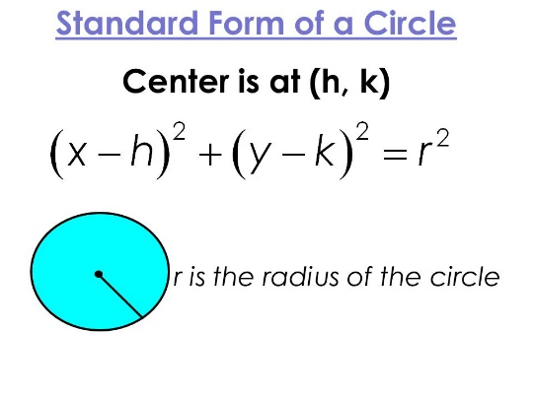](http://www.google.com/url?sa=i&rct=j&q=&esrc=s&source=images&cd=&cad=rja&uact=8&ved=0ahUKEwji8fv--6vPAhWLKCYKHciPDkMQjRwIBw&url=http://slideplayer.com/slide/6070989/&bvm=bv.133700528,d.eWE&psig=AFQjCNEfGPVoPlU5nmGpus5kvF6U5Fxrww&ust=1474942726058425)

1. Write an equation of a circle that is centered at (-5, 2) and is tangent to the x-axis.
2. Write an equation of a circle that is centered at (-1, 4) and contains the point (3, 6)

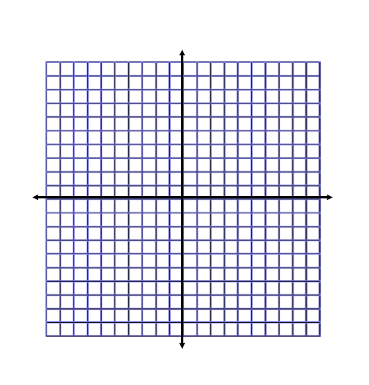

1. Graph the following circles to the right.
2. 
3. 
4. Find the exact area and circumference of the circles above.
5. Put the equations above from #4 into ‘standard form’ like we did for #1h.

1. Determine the center and radius of the given circles below by completing the square.

Steps for completing the square

1. Re-arrange the terms (put x terms and y terms near each other on the same side, move all constant terms to the other side).
2. Add a blank space next to the x term, next to the y term, and two blank spaces to the other side of the equation.
3. Take half the coefficient of x, square it, and add it to both sides.
4. Take half the coefficient of y, square it, and add it to both sides.
5. Factor the side containing the variables and combine like terms on the other side of the equation.
6. 

b. 

1. 
2. Find the exact circumference of the circle below. No calculator!!

