AP Calculus AB **NO CALCULATOR**  Name__________________________________

Lessons 2-1 & 2-2 Learning Check – *Limits* Date _______________________________

Result (circle one): P or NP

1. Determine . 1. ________

(A) 0 (B) 5 (C) 6 (D) does not exist

2. Which of the following is a horizontal asymptote for ? 2. ________



(A) (B)  (C)  (D) 



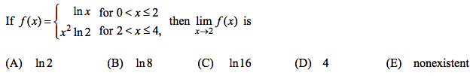

3. 3. ________

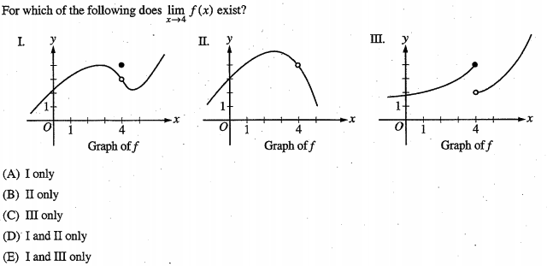

4. 4. ________

5. Find  algebraically/analytically. *Show your work*.