Math 3 Name: ________________________
2-2 Homework

Round all work to the thousandths place (3 decimal places). Show all work!

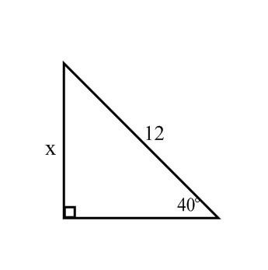
In 1-8, Find x

1.

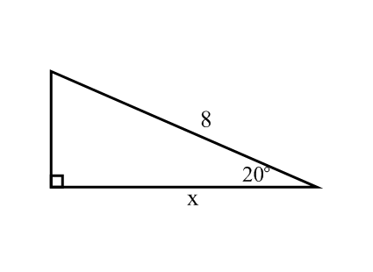

2.

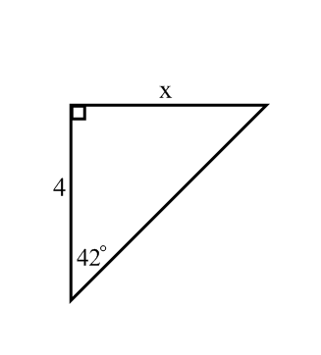

3.

4. A ladder leans diagonally against a wall. It makes a 60 degree angle with the ground. It reaches a height of 10 feet up the wall. How long is the ladder?

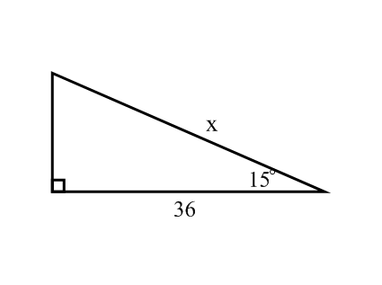

5.

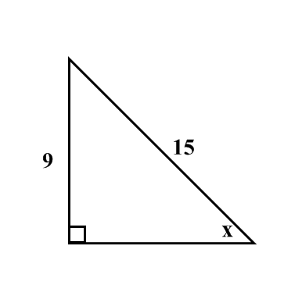
6.

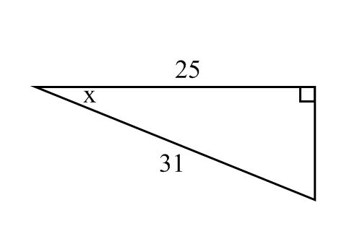
7.

8. A kite has a string that is 300 ft. long. One end is tied to a stake in the ground. If the angle the string makes with the ground is 72 degrees, how high up in the air is the kite?

