Math 3 Name__________________________________  
*2-2 Review of Trigonometry*

* *I can use sine, cosine, and tangent to find a missing side length or angle measure in a right triangle.*

Unit 2 deals with properties of Circles & Trigonometry. This may seem strange to you because Trigonometry (SOH CAH TOA) deals with the study of right triangles and circles are definitely not right triangles! This unit will show how these two seemingly unrelated topics are intertwined in upper level mathematics.

Recall the mnemonic SOH CAH TOA for right triangles:

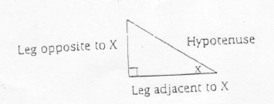

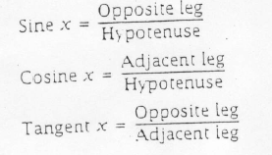

Directions: Find each trig ratio and leave your answer as a fraction. *You do not need to solve for anything yet.*

1. 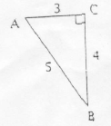
2. 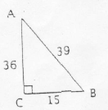

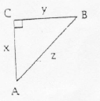

1. 

Directions: Find the missing side length x in the triangles below. Show all work. Circle your final answers. Round to the thousandths place.

1. 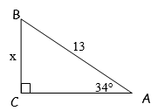
2. 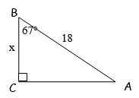

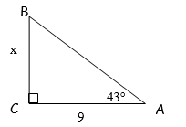

2. 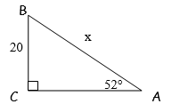

Directions: Find the missing angle measure x in the triangles below. Show all work. Circle your final answers. Round to the thousandths place.

1. 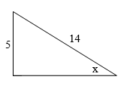

1. 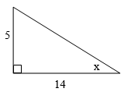
2. 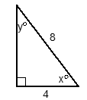
3. 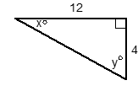

***Directions:*** For all word problems without a diagram, you are required to draw and label your own. Please show all work and calculations and round to the thousandths place when necessary. Be sure to label all units of measurement.

1. A 50 foot pole casts a shadow of 42 feet. At that particular moment, find the angle of elevation of the sun (the non-right angle closest to the ground).
2. A little boy is flying a kite. The string of the kite makes an angle of 30 degrees with the ground. If the height of the kite is 24m above the ground, find the length of the string that is being used by the boy. Assume that the string is taut.
3. A submarine at the surface of the water makes an emergency dive. The path that the sub takes makes an angle of 21 degrees with the surface of the water. How deep will the sub be if it dives 300 meters along its diagonal downward path? What is the horizontal distance that the sub traveled from where the sub first started to dive?
4. A 5.2 meter ladder leans against a wall. The bottom of the ladder is 1.9 meters from the wall. What angle does the ladder make with the ground (to the nearest tenth)?