Math 3 Name_______________________________

2-3 Practice

Find the values of the following expressions. Do NOT use a calculator. Your answers should be exact values. The radius of each circle is 1 unit.

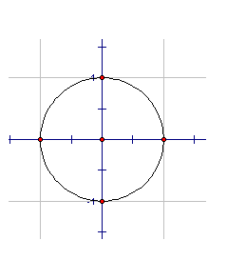1.  2. 

3.  4. 

5.  6. 

7.  8. 

9.  10. 

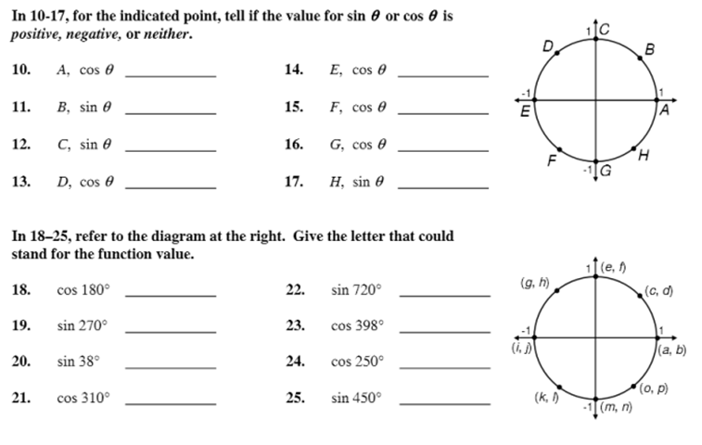

26.  27. 

28.  29. 

30.  31. 

32.  33. 

Solve for *x* in the following equations. Give all answers within one positive rotation around the circle.

25.  26. 

27.  28. 

29.  30. 