Math 3 Name_______________________________

2-3 *Unit Circle Exact Values in Degrees Part 1*

* *I can use sine and cosine functions to describe rotations of circular functions*
* *I can use degree measures to measure angles and rotations*
* *I can evaluate exact values for sine, cosine, and tangent around the unit circle*

Recall from geometry that an **angle** is the union of two rays (its **sides**) with the same endpoints (its **vertex**).

An angle can be thought of as being generated by rotating a ray either counterclockwise or clockwise around its endpoint from one position to another. For instance, in  below, you can think of  as the image of  under a counterclockwise rotation with center *Q*. The **measure** of an angle is a number the represents the *size and direction* of rotation used to generate the angle. In *trigonometry*, angles generated by a counterclockwise rotation are measured with positive numbers, and angles generated by clockwise rotations are measured with negative numbers.

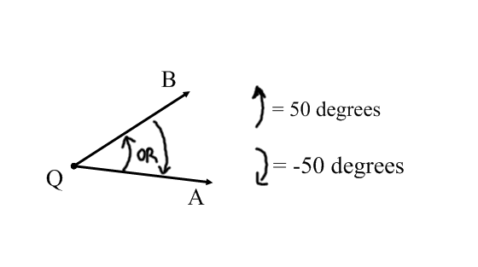

So far to this point in your illustrious mathematical careers, you have learned to measure angles in *degrees*. For instance, the measure of  above has a measure of 50 degrees. If  is considered the **initial side** and  is its image under a counterclockwise rotation (called the **terminal side**), then m = . However, if  was the initial side and rotated clockwise around *Q* so that  is the terminal side, then *m* = . *Be sure you understand the idea of positive and negative angle measures before moving on!!!!!*

Another unit for measuring rotations is the **revolution.** Revolution is related to degrees by the following formula: 1 revolution counterclockwise = . Some examples for equivalent degree measures are shown below.

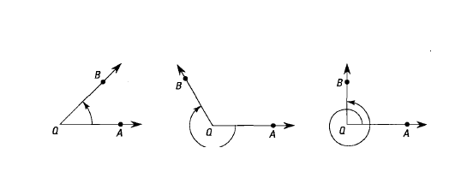

*Fig. A Fig. B Fig. C*

 revolution counterclockwise  revolution clockwise  revolution counterclockwise

  

Notice that the same rotation can have many different magnitudes. Fill in the blanks below

In figure B, the measurement of the angle is  revolution clockwise or -240 degrees. This is equivalent to a _____ revolution counterclockwise and ______ degrees.

In figure C, the measurement of the angle is  revolutions counterclockwise or 450 degrees. This is equivalent to both a _______ revolution counterclockwise and ______ degrees (rotating

counterclockwise) *and ______* revolution clockwise and ______ degrees (rotating clockwise).

**Practice**

If the terminal side of an angle rotates of a revolution counterclockwise from the initial side, how many degrees is the angle?

If an angle is , what is the measure of the angle in revolutions?

If the terminal side of an angle rotates of a revolution clockwise from the initial side, how many degrees is the angle?

Rip off the last page of this packet and use it and a protractor to complete the following activity. **The circle on the grid is called a *unit circle* because it has a radius of 1 unit.**

1. Use a protractor to mark the rotation of the point (1, 0) under a rotation of $50°$*counterclockwise* (in math, counterclockwise is considered a positive). Call this new point P­1

2. Use the grid to estimate the coordinate of the x-coordinate and the y-coordinate of P1 and the slope of.

x-coordinate:_______ y-coordinate:_______ slope of :_______

3. Set your calculator to degree mode. Use your calculator to find sin $50°$, cos $50°$, and tan $50°$

cos 50 = _______ sin 50 = _______ tan 50 = _______

4. Use a protractor to mark the rotation of the point (1, 0) under a rotation of 100 degrees. Call this new point P2

5. Use the grid to estimate the coordinate of the x-coordinate and the y-coordinate of P2 and the slope of

x-coordinate:_______ y-coordinate:_______ slope of:_______

6. Set your calculator to degree mode. Use your calculator to find sin $100°$, cos $100°$, and tan $100°$

cos 100 = _______ sin 100 = _______ tan 100 = _______

7. Look back at your work from 1 – 3 and 4 – 6. What relations do you see between the coordinates of the image of (1, 0) under a rotation of magnitudeand the values of cos,sin , and tan?

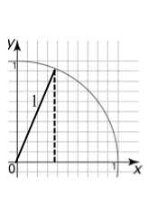

**NOTES:** Use the first quadrant and the fact that the radius of the unit circle is 1 to explain why your answer to number (7) is correct.

8. **Without a calculator**, find sin  (*hint: where is*  *located on the circle? What is the coordinate of that point?*) Find .

9. How is tan related to sin and cos?

**For angles on the unit circle, generally represented by the Greek letter $θ$, it is assumed that the**

**vertex of the angle is (0, 0) and the initial side of the angle has an endpoint of (1, 0)**

10. Based on what you have discovered, what is the coordinate of a point on the unit circle that has an angle of $30°$? Check your answer using your protractor and the unit circle.

11. What angle has coordinates of (0.7071, 0.7071).

12. Find the coordinates (to the nearest thousandth) on the unit circle if $θ$ is the following:

a. $40°$_______________ b. $150°$

_______________

c. $\frac{1}{3}$ revolution ____________ d. _______________

13. The coordinate (0.3907, 0.9205) is on the unit circle. Using your knowledge of the symmetry of a circle, what other coordinates must also be on the circle?

14. What angle represents a rotation from (1, 0) to the coordinate (0.3907, 0.9205)?

15. Using your knowledge of the symmetry of a circle (and NOT any trigonometric functions), find the angles that represent the other coordinates from number (13).

**NO CALCULATOR FROM THIS POINT ON!!!**

While we can use our sandbox trigonometry to find values on the unit circle, we will generally have to round those values. However there are some ***exact value*** coordinates on the unit circle, such as the coordinates at angle rotations of $0°.90°, 180°, 270°$, and $360°$ (and all their multiples).

16a. Without using a calculator, find the coordinates on the unit circle if $θ$ is the following:

a. $90°$________ b. $180°$

________

c. $270°$________ d. $360°$

________

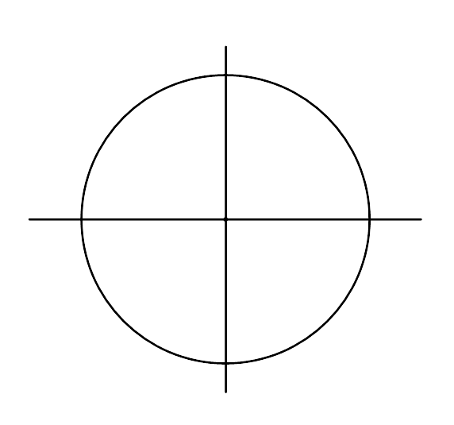16b. Based on your answers to part (a), find the following **exact values**:

a.  b. 

c.  d. 

e.  f. 

g.  h. 

i.  j. 

k.  l. 

17. We should also be able to find tangent values for locations on the unit circle that fall on the lines

. Identify those 4 places on the unit circle below and find the tangent values below.

a.  b. 

c.  d. 

e.  f. 

g.  h. 

Space for additional notes if needed:

