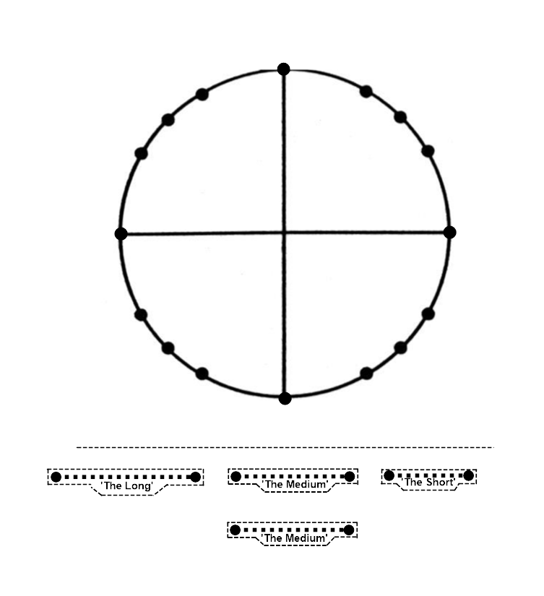Math 3  Name____________________________

2-3*Unit Circle Exact Values in Degrees Part 2* **NO CALCULATOR!!**

**Recall the following:**

* The unit circle (on the front page) is centered at the origin and has a radius of 1.
* We always rotate the point (1,0).
* If we rotate positive  degrees, we rotate counterclockwise.
* If we rotate negative  degrees, we rotate clockwise.
* The image of (1, 0) under a rotation of  degrees is a point located at 

1. Carefully separate the front page from the rest of the packet and continue to #2 below.
2. Rotate (1, 0) around the unit circle in increments of 30 degrees and write the number of degrees rotated from (1, 0) near each point.

*Note: Every point will not end up with an angle measure when you count by 30 degrees.*

1. Now rotate (1, 0) around the unit circle in increments of 45 degrees and write the number of degrees rotated from (1, 0) near each point that does not already have a degree value.
2. We know the coordinates of the 4 points that are either on the x-axis or the y-axis.

Label the coordinates of those 4 points on the unit circle.

1. Keeping in mind that: cos() = x-coordinate,

sin() = y-coordinate, and

tan() =  (or slope of the terminal side)

Find all of theexact values below using your unit circle on the front page.

All  values are in degrees. Remember to always rotate from point (1, 0).

**NO CALCULATOR!**

a. cos(270) = b. tan(720) = c. sin(-270) = d. sin(-90) =

e. tan(-450) = f. tan(90) = g. tan(-180) = h. cos(180) =

i. cos(450) = j. sin(540) = k.cos(0) = l. sin(-360) =

1. Check your answers to #5with your teacher before getting scissors for #7
2. Luckily, when you start at the origin and try to plot the points printed on your unit circle that you do not already have coordinates for, there are only 3 possible exact distances that you have to move left or right from the origin, and the same 3possible exact distances that you have to move up or down from the x-axis to reach any point. This is only the case for the points not on the x or y-axis that we do not already have coordinates for.
   1. Carefully cut off the bottom of the front page using scissors and then cut out all 4exact distances by carefully cutting along the dotted lines.
   2. Gather your trash, throw it out, and put your scissors back.
   3. The exact distances for the cutouts are as follows:



* 1. Use your exact distance cutouts to find the remaining coordinates for the points on your unit circle. Write them carefully on the circle using their exact lengths values in the box above. *Note: X and Y coordinates can be positive and negative. Think before you write!*

1. After filling in all of the coordinates on your unit circle, check to make sure your coordinates are correct with your teacher before moving on.
2. Find all of the exact values below using your newly completed unit circle on the front page. All  values are in degrees. Remember to always rotate from point (1, 0).

**NO CALCULATOR!**

a. cos(60) = b. sin(-30) = c. sin(120) = d. cos(135) =

e. cos(-150) = f. sin(-315) = g. sin(315) = h. cos(300) =

i. sin(-330) = j. sin(240) = k. cos(225) = l. sin(870) =

1. Check your answers to #9 with your teacher before moving on to #11.
2. **Without looking at your completed unit circle, or your work from #9**, find all of the exact values below. All  values are in degrees.

Use the idea of “long” “medium” and “short” to help you.

Write the exact length for the long, medium, and short below before starting.

Look back for the values if you need to.

You need to memorize these values as short, medium, and long.

Long = Medium = Short =

**Once Again - DO NOT LOOK AT YOUR COMPLETED UNIT CIRCLE AND DO NOT USE A CALCULATOR!**

Think about where the rotation takes you on the unit circle. Find that place

Place your point carefully in the correct place within the correct quadrant on the circle.

Think if they want an x or y coordinate.

Think about if the x or y coordinate is positive or negative.

Think about if the x or y coordinate is long, medium, or short in that quadrant.

Recall the exact value for the long, medium, or short from your table above.

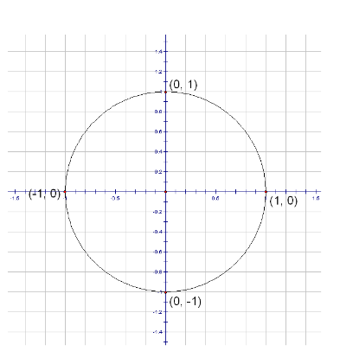Write the exact value as either a positive or a negative value.

Write lightly in pencil and erase your markings on the circle after each problem.

a. cos(30) = b. cos(240) = c. sin(-135) = d. cos(60) =

e. sin(210) = f. cos(45) = g. cos(315) = h. sin(-60) =

i. sin(-300) = j. cos(330) = k. cos(120) = l. sin(135) =

1. Check your answers above with your teacher before moving on to #13.

**Recall the following:**

* The initial side of a rotation is the line segment with endpoints (0, 0) and (1, 0)
* The terminal side of the rotation is a line segment with endpoints (0, 0) and 
* The slope of the terminal side is called the tangent of 
*  slope of the terminal side
  + If a terminal side is horizontal, it has a slope of 0.
  + If the terminal side is vertical, the slope is undefined.

1. Locate the terminal sides that are either vertical or horizontal and correctly label them with their tangent values. Use the information above to help you determine the value.
2. In the first quadrant only, label the unlabeled terminal sides as either “**most steep**”, “**medium steep**”, or “**least steep**”.
3. Label the terminal sides in the remaining 3 quadrants like we did in the first quadrant. Work in one quadrant at a time.
4. After checking with your teacher to make sure you have correctly labeled the terminal sides, move on to #17.

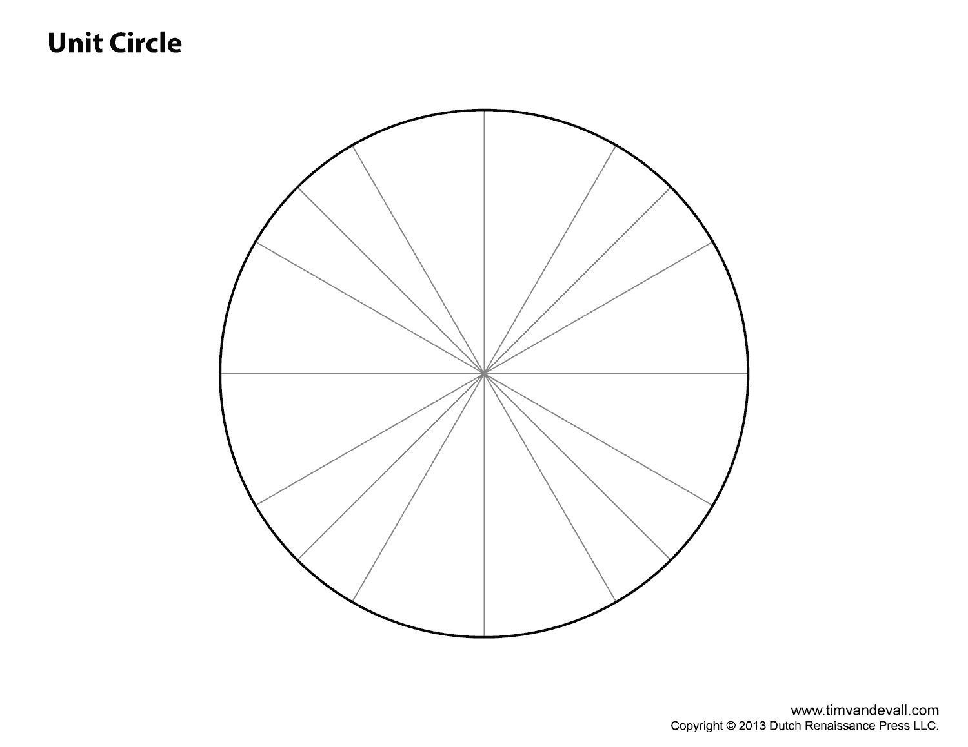

1. Remember, when you find slopes of the terminal sides, you are really determining the Tan().

Luckily, besides 0 and undefined, there are only 3 other exact values for Tan(). The values are based off of slope and the idea of “**most steep**”, “**medium steep**”, or “**least steep**”.

Since slope can be positive and negative, the exact tangent values below can be both positive or negative depending on if the slope of the terminal side is positive or negative.



Keep in mind that the values above are either positive or negative in value. One terminal side cannot have a slope that is both positive and negative.

1. The Tangent values based off of steepness (or slope) that I need to memorize are:

Most Steep = Medium Steep = Least Steep =

(this one you already know)

1. Carefully draw in the missing terminal sides in the unit circle below. Then use the idea of steepness and the tangent values in the table above to carefully label the tangent values for the entire unit circle below. Remember, some will be negative, and some will be positive based on whether the terminal side is increasing or decreasing. Think in terms of steepness and slope!

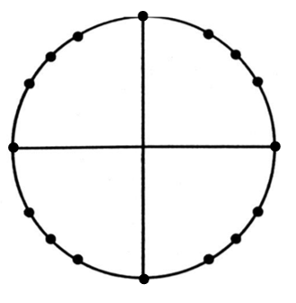

1. After checking with your teacher to make sure you have correctly labeled the unit circle from #17 with tangent values, carefully place the correct tangent values on your unit circle that you ripped off.
2. Great job! Now you will put all of this knowledge to good use and show off what you learned. Try not to look back, and use the idea of long distance, medium distance, short distance, most steep, medium steep, and least steep to help you. Remember, this isn’t a race, take your time and think!!

Find the following exact values WITHOUT looking at your completed unit circle.

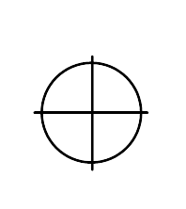**No Calculator!**

a.  b.  c. 



d.  e.  f. 



g.  h.  i. 





j.  k.  l. 