Math 3 Name_______________________________

2-4Radians Exact Values Practice

Find the values of the following expressions. Do NOT use a calculator. Your answers should be exact values. The radius of each circle is 1 unit.

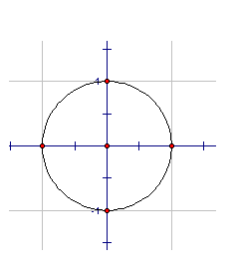1.  2. 

3.  4. 

5.  6. 

7.  8. 

9.  10. 

11.  12. 

13.  14. 

15.  16. 

17.  18. 

19.  20. 

21.  22. 

23.  24. 

25.  26. 

27.  28. 

29.  30. 