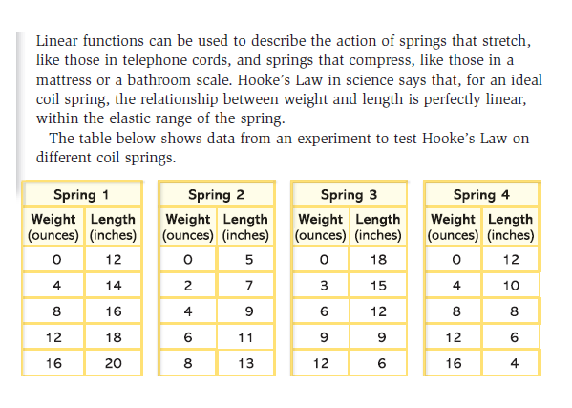Math 1  Name__________________________________  
**2-4 Homework** Date_________

1.

1. Identify the length of the spring with no weight applied.

|  |  |  |  |
| --- | --- | --- | --- |
| **Spring 1** | **Spring 2** | **Spring 3** | **Spring 4** |
|  |  |  |  |

1. What is the rate of change of the length of the spring as weight is increased? Indicate units.

|  |  |  |  |
| --- | --- | --- | --- |
| **Spring 1** | **Spring 2** | **Spring 3** | **Spring 4** |
|  |  |  |  |

1. Decide whether the experiment was designed to measure spring *stretch* or spring *compression*.

|  |  |  |  |
| --- | --- | --- | --- |
| **Spring 1** | **Spring 2** | **Spring 3** | **Spring 4** |
|  |  |  |  |

1. Write a recursive equation to show how the spring length changes with each addition of one ounce of weight.

|  |  |  |  |
| --- | --- | --- | --- |
| **Spring 1** | **Spring 2** | **Spring 3** | **Spring 4** |
|  |  |  |  |

1. 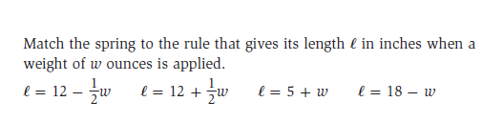

|  |  |  |  |
| --- | --- | --- | --- |
| **Spring 1** | **Spring 2** | **Spring 3** | **Spring 4** |
|  |  |  |  |

|  |  |  |  |
| --- | --- | --- | --- |
| **Spring 1** | **Spring 2** | **Spring 3** | **Spring 4** |
|  |  |  |  |

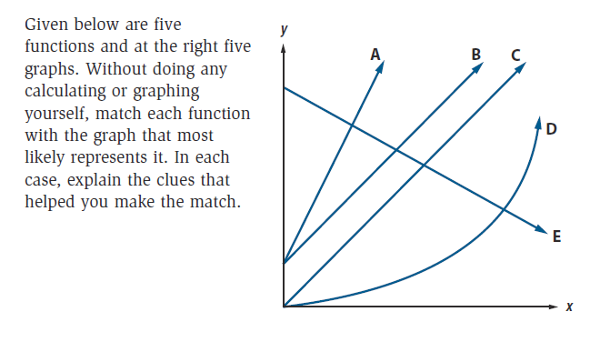

2.

a.  🡪 Matches Graph ______ Explanation: __________________________________________

b.  🡪 Matches Graph ______ Explanation:_______________________________________

c.  🡪 Matches Graph ______ Explanation:________________________________________

d.  🡪 Matches Graph ______ Explanation:________________________________________

e.  🡪 Matches Graph ______ Explanation:______________________________________

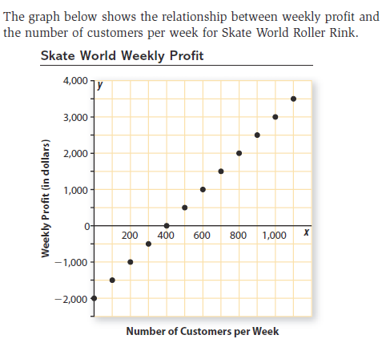3.

1. Determine the slope and *y*-intercept of the line that fits this data.
2. Explain what the slope and *y-*intercept of the line tell you about the relationship between Skate World profit and the number of customers per week.

Slope:

*y*-intercept:

4. Recall the formulas for circumference of a circle and for area of a circle. They are listed below.



1. Is circumference a linear function of the radius of a circle? In other words, is the *C* equation linear? Explain how you know.
2. Based on the equation, how does the circumference of the circle change as the radius increases?
3. Is the area formula a linear equation? Explain how you know.
4. What does the formula tell you about how the area changes as the radius increases?

5. Which of the situations below involve linear functions and which do not? Explain your reasoning.

*Remember: *

a. If a race car averages 150 miles per hour, the distance (*d*) covered is a function of the driving time (*t*).

b. If the length of a race is 150 miles, the time *t* to complete the race is a function of the average speed or rate *r*.

1. If the length of a race is 150 miles, the average speed *r*  for the race is a function of race time *t*.

**Review**

6. Which term of the sequence is -162.5?