Math 3 Name _________________________
2-4 Exact Values Practice
Determine the exact value of each expression without a calculator:
$$3. cos{\frac{4π}{3}}$$
$$2. sin{\frac{11π}{6}}$$
1. $\sin{\frac{3π}{4}}$

$$6. sin\left(-\frac{5π}{3}\right)$$
$$5. sin\left(300°\right)$$
$$4. tan{\frac{7π}{6}}$$
$$9. cos\left(-\frac{19π}{6}\right)$$
$$8. sin\left(315°\right)$$
$$7. cos{\frac{7π}{4}}$$

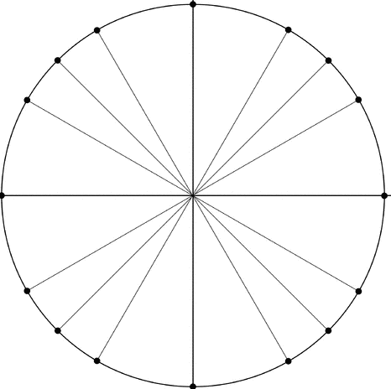
$$12. tan\left(\frac{14π}{3}\right)$$
11. $tan-{\frac{5π}{4}}$
$$10. cos{\frac{11π}{3}}$$

