Math 3 Name_______________________________

2-4 *Unit Circle Exact Values (Radians), part 1*

Learning Goals:

* *I can use sine and cosine functions to describe rotations of circular functions*
* *I can use radian and degree measures to measure angles and rotations*
* *I can evaluate exact values for sine, cosine, and tangent around the unit circle*

**Radian Measure**

One way of measuring angles that you have most likely not done to this point in your mathematical careers is the **radian measure** of an angle. *The radian measure of an angle is determined by joining the center of a circle to the endpoints of an arc equal in length to the radius of the circle*. It sounds complicated, but it really is not. See the following exploration below.

1. You will be given a sheet of paper with several circles with center A. For each circle, break a twizzler so that it is the length of the radius of the circle.

2. Use the radius-length twizzler to mark an arc on the circle that is the length of the radius (call one endpoint B and the other endpoint C).

3. Measure the angle that is made by connecting the center of the circle to the two endpoints of the arc.

For the circle in Figure 1,  ________

For the circle in Figure 2,  ________

For the circle in Figure 3,  ________

For the circle in Figure 4,  ________

What do you notice about all the measurements above?

Reread the italicized definition of a radian above. Based on the work you just did above, no matter what size the radius of a circle is, in terms of degrees the measure of 1 radian  ________ degrees.

A semi-circle is one-half of a circle. How many degrees are in a semi-circle?________

How many radians are in a semi-circle? Use your work above to convert.

Semi-circle = _________ radians

The number that you wrote for the above answer seems pretty close to what other famous and important number in mathematics?_______. Based on rounding and measurement error that may have occurred, and the fact that our answer is very close to this famous number, fill in the following again:

Semi-circle = _________ radians. Therefore, the measure of an entire circle is as follows:

**1 revolution = _______ degrees = _______ radians**

**Why are radians important?**

The mathematical appeal of radian measure lies in the way that it enables use of linear measurement ideas and tools to produce meaning ful measurement of angles and rotations. For example, suppose you wanted to measure and the only available tools were a tape measure marked off in inches and a compass.

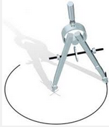

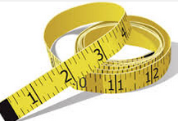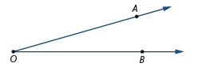

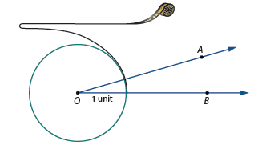To measure the angle in radians, you could draw a circle with center *O* and radius equal to one inch. Then wrap the tape measure around the circle, starting where meets the circle and noting the point on the tape measure where meets the circle.

The arc length indicated on the tape measure will be the radian measure of the angle!

Because radian measure connects points on a number or time line axis to points on a circle with a common unit of measurement, it is customary to use radian measure in analyzing circular motion as a function of time. We will investigate this idea in more detail in the coming lessons.

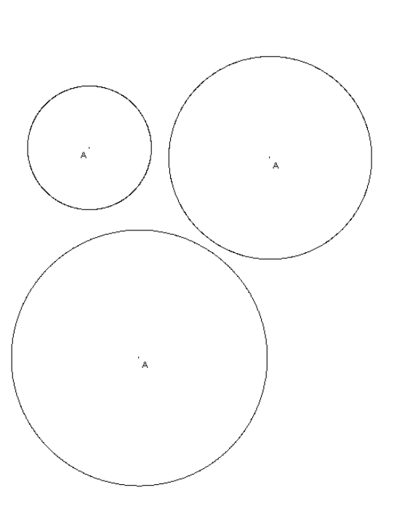



Math 3 Name_________________________________

2-4 *Unit Circle Exact Values (Radians), part 2*

Quick Mental Math facts pertinent to the Unit Circle

**If applicable, write each as an improper fraction**

=

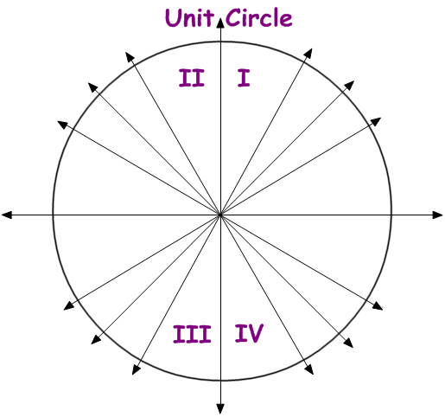

=

=

=

=

=

=

=

=

=



**Use the below unit circle to answer the questions that are sent to you on the Navigator.**

**We will be simply trying to locate radian measures of angles around the unit circle!**

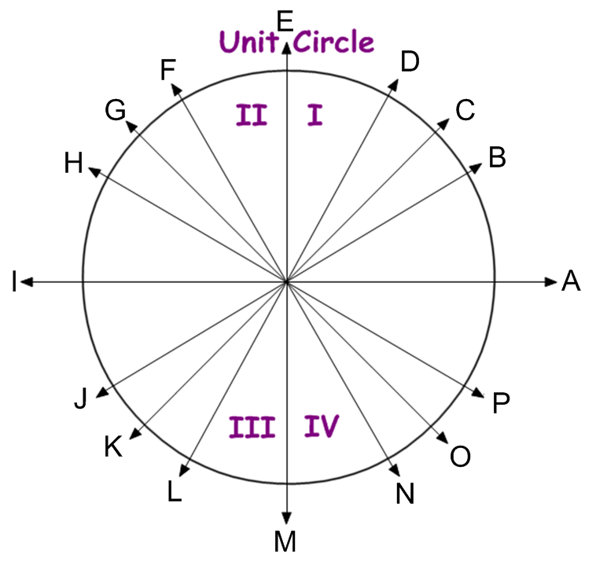

**Practice:**

Find the values of the following expressions. Do NOT use a calculator. Your answers should be

exact values. All circles below are unit circles.

1.  2.  3. 

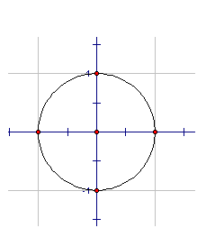

4.  5.  6. 



7.  8.  9. 

10.  11.  12. 

13.  14.  15. 



16.  17.  18. 



19.  20.  21. 

22.  23.  24. 

25.  26.  27. 



28.  29.  30. 



31.  32.  33. 

34.  35.  36. 