Math 3 Name_______________________________

2-5 *Graphs of Trigonometric Functions* Notes

1. Using your knowledge of the unit circle, complete the table below.

|  |  |
| --- | --- |
|  |  |
|  |  |
|  |  |
|  |  |
|  |  |
|  |  |
|  |  |
| 0 |  |
|  |  |
|  |  |
|  |  |
|  |  |
|  |  |
|  |  |

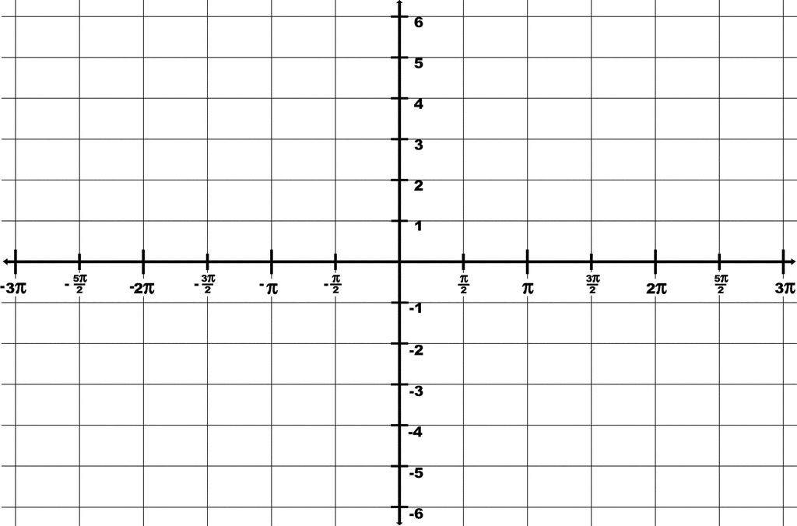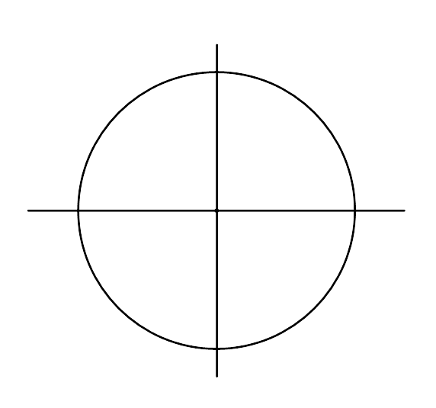

1. Use your completed table above to complete the graph above for  by plotting points and fitting a curve through the points. (There should be no jagged edges on your graph!)
2. State the domain, range, and y-intercept of 
3. Using your knowledge of the unit circle, complete the table below.

|  |  |
| --- | --- |
|  |  |
|  |  |
|  |  |
|  |  |
|  |  |
|  |  |
|  |  |
| 0 |  |
|  |  |
|  |  |
|  |  |
|  |  |
|  |  |
|  |  |



1. Use your completed table above to complete the graph above for  by plotting points and fitting a curve through the points. (There should be no jagged edges on your graph!)
2. State the domain, range, and y-intercept of 
3. 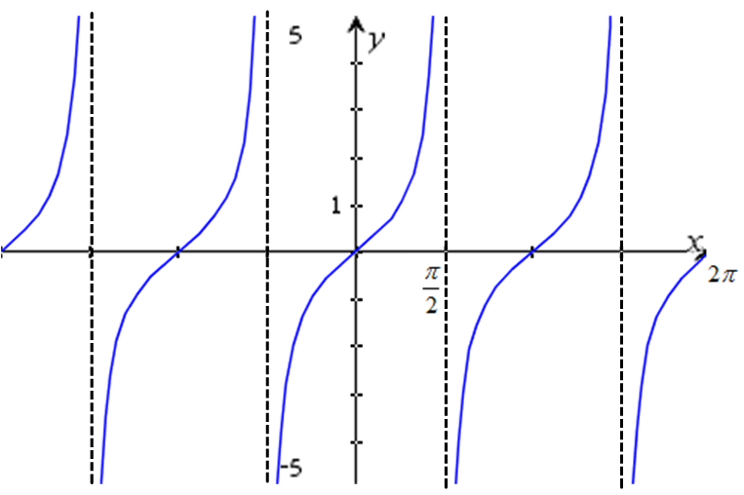Below is a graph of (the *x*-axis is in radians)
4. What is happening at ? Why?
5. Is the domain all real numbers for ? Why?
6. What is the range of ?
7. Go back and determine the period for all 3 graphs that we looked at. The period of a trig function is how much you must rotate before the graph begins to repeat itself.
8. Determine the amplitude for the sine and cosine curves you graph. The amplitude is half the distance between the maximum and minimum y-coordinate.