Math 1 Name ______________________________
2-5 Point-Slope Homework Date________
$$y-y_{1}=m(x-x_{1})$$

1. Find the equation of a line with the given slope and point on the line. Express your answers in point slope form.
a. m = 2 and (-1, 3)
b. m = -2 and (-5, -2)

c. m = 3 and (0, 10)

2. Find the equation of the line that passes through the given two points. Express your answers in point slope form.
a. (-4, 7) and (6, -3)

b. (1, 12) and (-3, 5)

c. (-6, 10) and (2, -5)

3. Given the equation $y – 5 = 6(x – 8)$
a. What is the slope?

b. Name a point that is on the line.

c. Find the y-intercept.
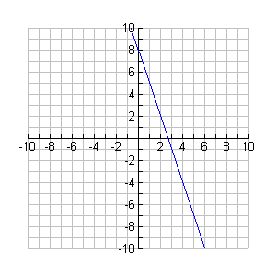
4. Write the equation of the line graphed below. Express your answer in point-slope form

5. Explain why it’s sometimes helpful to use point-slope form instead of slope-intercept form?

