Math 1 Name ______________________________  
**2-5 Practice 2** Date________

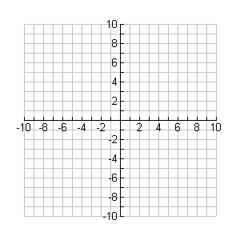Graph each of the following lines by first giving the point and the slope. Then rewrite the equation in slope-intercept form.

1. $y+2=\frac{1}{3}(x+6)$

Point _________

Slope _________

Slope-Intercept Form _________



2. $y+1=-\frac{1}{2}(x-3)$

Point _________

Slope _________

Slope-Intercept Form _________



3. $y-5=3x$

Point _________

Slope _________

Slope-Intercept Form _________

4. Given a slope of -2 and the coordinate (3 , -4) write the equation of the line in point-slope form.

5. Write the equation of a line through (-1 , 5) and (-2 , 8) in point-slope form. (Use (-1 , 5) in your formula.)

6. Write *g*(-5) = 2 as an ordered pair.

7. Evaluate the function *j*(*x*) = for j(-5) =

8. Evaluate the function *t*(*x*) = for *t*(-4) =

9. Evaluate the function *k*(*x*) = 6*x* + 5 when *k*(*x*) = 23

10. Evaluate the function *n*(*x*) = $x^{2}-5$ when *n*(*x*) = -1

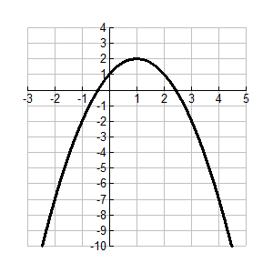11. Given the graph of *f*(*x*) to the right.

1. Find 
2. Find 
3. Find 
4. Find the average rate of change from *x* = -1, to 4.

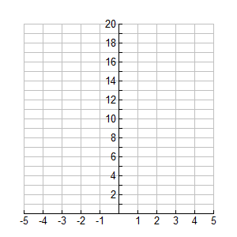12. Find the equation in slope-intercept form for the coordinates (3, 4) and (7, -12). Then graph it.

13. Solve the following: 

1. The football team decides to start selling jerseys to make more money to get new equipment for the weight room. The seniors did a survey and found that if they charge $30 a jersey, 175 students would buy one. If the price was $22 a jersey, then 287 students would buy one.
2. What is the independent variable? What is the dependent variable?
3. What is the rate of change in jerseys sold as the price per jersey increases from $22 to $30?

The rate of change is _______________ (*include units)*

1. Assume that sales are a linear function of price. Use the rate of change you found in Part *a* to reason about how many jerseys would be purchased for a price of $0.
2. Use your answers to Parts *a* and *b* to write a rule for calculating expected sales  for any price *x* in dollars.
3. Use your rule to estimate the expected number of jerseys sold if the price was set at $25.
4. What price should be charged if they want to sell 427 jerseys?
5. What is the practical domain? What is the practical range?