Math 1 Name__________________________________
2-5 Homework - Writing Linear Functions Date_________
Write recursive and explicit formulas for the linear functions that are given in the following tables and graphs. Make sure to write your explicit formula completely simplified and in function notation.
x | f(x)
5 | 20
15 | 40
25 | 60
35 | 80
x | f(x)
-1 | 8
0 | 5
1 | 2
2 | -1
1. 2.

Recursive: Recursive:

Explicit: Explicit:

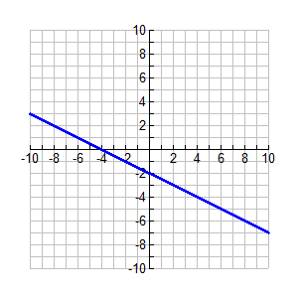
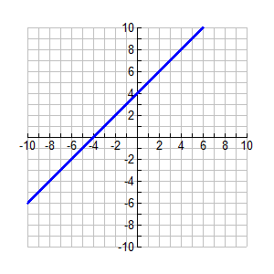
3. 4.

Recursive: Recursive:

Explicit: Explicit:
You just got hired for your first job. You are delivering newspapers to the neighborhood houses. You will be paid $15 a day plus $0.10 per newspaper you deliver.

- What is the independent variable? ___________________________

- What is the dependent variable? ____________________________

Fill in the table. Label the first row with your independent and dependent variables.
-1
0
1
50
75
200
250

- Does the table appear to be linear? Explain.

- What is the slope of the data in the table? ________ What does the slope mean in the context of the problem situation?

- What is the y-intercept of the data in the table? _________ What does the y-intercept mean in the context of the problem situation?

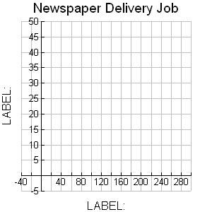
- Plot your data points from your table on the graph.

- On your graph label the x and y axes with
the appropriate terms.

- On the graph show how to calculate the
slope of the line.

- Circle the y-intercept on the graph.

- You plotted the point (-1, ________) on the graph. What does this mean in the context of the problem situation?

- Using function notation, write a rule that represents the situation. You will need to choose the independent and dependent variables (meaning, you need to pick the actual letters you will use in the equation).
- Graph your rule on the coordinate plane to the right.

- How does your graph from number 11 compare
to the one from number 6?

- Write a recursive rule to represent the situation.

- What is the practical domain for this situation?

- What is the practical range for this situation?

