Math 1 Name_________________________

**2-5 Writing and Interpreting Functions in Context and Forms of Linear Equations** Date________

*Learning goals:*

* *I can verify and explain that every point (x, y) on the graph of an equation represents values x and y that make the equation true.*
* *I can write explicit/recursive equations to describe a real-world problem.*
* *I can identify, graph, and write an equation for a linear function in a variety of forms including, but not limited to: standard, point-slope, slope-intercept.*
* *I can define and calculate the average rate of change of a function and explain the connection between average rate of change and slope.*
* *I can identify and explain the meaning of the x and y-intercept in the context of a problem.*

1. The student council at Mayfield High School decided to rent a dunking booth for a fundraiser. They were quite sure that students would pay for chances to hit a target with a ball to dunk a teacher or administrator in a tub of cold water. The dunking booth costs $150 to rent for the event, and the student council decided to charge students $0.50 per throw.
2. How do you know from the problem description that *profit* is a linear function of the *number of throws*?
3. Write a recursive formula that shows how fund-raiser profit changes with each additional customer.
4. Write a rule in function notation that shows how to calculate the profit *P* in dollars if *t* throws are purchased. Explain the thinking you used to write the rule.

*Rule:­*_____________________

*Explanation:*

1. What do the coefficient of *t* and the constant term in your rule from Part *c* tell about the graph of profit as a function of number of throws?
2. What do the coefficient of *t* and the constant term in your rule from Part *c* tell about a table of sample (*number of throws*, *profit*) values?
3. Every business has to deal with two important patterns of change, called *depreciation* and *inflation*. When new equipment is purchased, the resale value of that equipment declines or depreciates as time passes. The cost of buying new replacement equipment usually increases due to inflation as time passes. The owner of Game Time, Inc. operates a chain of video game arcades. They keep a close eye on prices for new arcade games and the resale value of their existing games. One set of predictions is shown in the graph below.
4. 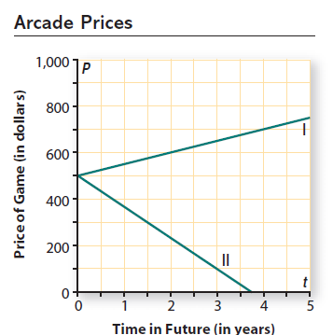Which of the two linear functions predicts the future price of new arcade games? Which predicts the future resale value of arcade games that are purchased now?

Graph I predicts ______________________________________.

I know this because. . .

Graph II predicts______________________________________.

I know this because. . .

1. For each graph, find the slope and y-intercept. Explain what these values tell about arcade game prices.

The slope of Graph I is _______, the *y*-intercept is ______. The slope tells me that __________

_____________________________, the *y*-intercept tells me that _________________________

_____________________________. The slope of Graph II is _______, the *y*-intercept is ______. The

slope tells me that _______________________________________, the *y*-intercept tells me that

______________________________________________________.

1. For each graph write a rule for calculating game price *P* in dollars at any future time *t* in years.

Rule for Graph I:

Rule for Graph II:

1. The Terrapin Candy Company sells its specialty candy through orders placed online. The company web page shows a table of prices for sample orders. Each price includes a fixed shipping-and-handling cost plus a cost per box of candy.

|  |  |  |  |  |  |  |
| --- | --- | --- | --- | --- | --- | --- |
| **Number of Boxes** | 1 | 2 | 3 | 4 | 5 | 10 |
| **Price** (in dollars) | 20 | 35 | 50 | 65 | 80 | 155 |

1. Explain why that price seems to be a linear function of the number of boxes ordered.
2. What is the rate of change in order price as the number of boxes increases?

*Be sure to show some work and/or explain your answer!*

1. Write a function rule for calculating the price *P* in dollars for *n* boxes of candy.
2. Use your function rule to find the price for 6 boxes and the price for 9 boxes of candy.

*Show your work!!!*

1. The Beachwood High School store sells bottled drinks before and after school and during lunch. During the first few weeks of school, the store manager set a price of $1.25 per bottle, and daily sales averaged 85 bottles per day. She then increased the price to $1.75 per bottle, and sales decreased to an average of 65 bottles per day.
2. What is the rate of change in average daily sales as the price per bottle increases from $1.25 to $1.75?

The rate of change is ______________________________ (*include units)*

1. Assume that sales are a linear function of price. Use the rate of change you found in Part *a* to reason about expected daily “sales” for a price of $0. Then explain why you would or would not have much confidence in that prediction.
2. Use your answers to Parts *a* and *b* to write a rule for calculating expected sales *S* for any price *p* in dollars.
3. Use your rule to estimate the expected daily sales if the price is set at $0.90 per bottle.

5. Each pair of points listed below determines the graph of a linear function. For each pair, give the following.

1. the slope of the graph
2. the y-intercept of the graph
3. a rule for the function
4. and  b. and 
5. and  d. and 

**Point-Slope Formula:** ***y – y1 = m*(*x – x1*)**

Use the point-slope formula to write the equation of a line through the following points and graph the functions.

6. (0, 5) and (2, 13) 7. (-3, 12) and (0, 10)

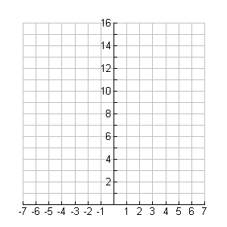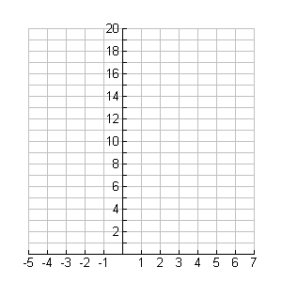

8. (-1, 6) and (1, 7) 9. (3, 9) and (5, 5)

