Math 1 Name ______________________________
2-7 Homework Date________

- We’ve all heard the expression that a 5 year old dog is said to be about “35 years old in human years.” How do they figure that out? Similarly, cats age in the same way. The data table below shows the ages of cats as related to the ages of humans, as observed by French veterinarian Dr. A. LeBeau.

Cat Age (years) | 0.5 | 1 | 2 | 4 | 6 | 8 | 10 | 14 | 18
Equivalent Human Age (years) | 10 | 15 | 25 | 32 | 40 | 48 | 56 | 72 | 91

- Is this data linear? Explain.

- What is the linear regression equation written in function notation?

- Correlation value: r = ________ Meaning:

- According to your equation how many ‘human years’ does a cat gain for each year?

- According to the equation, how old would a newborn cat be in human years? Does that answer make sense?

- According to the equation, how old ‘in human years’ would a cat be at age 7?

- According to the equation, how old ‘in human years’ would a cat be at age 20?

- According to the equation, if a cat is said to be 75 in human years, what is their actual age?

- Sometimes, data in real life can be linear. It can be then useful to find the equation that best fits the data, even if it is not perfectly linear.

The following table shows the average weight of a girl compared to her age.

Age | 0.5 | 1 | 2 | 3 | 4 | 6 | 8 | 10
Weight (in lbs.) | 15.9 | 20.1 | 24.9 | 30.0 | 33.1 | 45.0 | 56.0 | 69.0

Graph this data on your calculator.

- Does it seem to be linear?

- What is the regression equation?

- What is your correlation coefficient and what does it tell us about the data?

- If the equation is accurate, what would you expect a girl to weigh at age 18?

- Will this data continue to be linear in the future?

- Correlation Coefficient: the number r on the calculator when you do regression.
A number from -1 to 1. r indicates the direction of the relation between he variables. If r is positive, the slope of the line is positive and the correlation is positive (the variables agree). If r is negative, the slope of the line is negative and the correlation is negative (the variables disagree).

- The closer r is to 1, the more positive the relationship (very strong accuracy).
- The closer r is to -1, the more negative the relationship (very strong negative accuracy.)
- The closer r is to 0, the less of a relationship there is (very weak accuracy).

After reading what it says above, describe what the following correlation coefficients would mean.

- r = .99928 _________________________________________________

- r = 0 __________________________________________________

- r = -.97546 __________________________________________________

- r = .67823 __________________________________________________

- r = -.21236 __________________________________________________

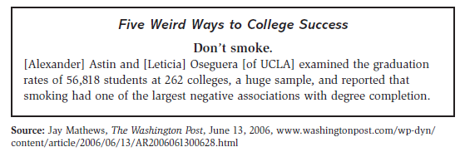
- Examine the following studies and decide if they are an example of correlation or causation. If there is a lurking variable, identify it.

