2014 Midterm review made by you
10 Questions on Bone Cartilage
- What are the bone forming cells?
- What are bone cells?
- Where can you find Canaliculi?
- Is a fracture and bone the same thing?
- Who most likely will get a greenstick fracture?
- What is the first step to bone healing after a fracture?
- Why are bones resistant to twisting forces?
- Name one difference between Osteoblasts and Osteoclasts
- What are the steps to Endochondral Ossification?
- T/F: Bones grow slimmer and longer in response to the stress put on them?
8 Questions on the Integumentary System
- Name the five layers of the epidermis.
- Name the layers of the dermis.
- What pigments can be attributed to coloring of the skin?
- Where are Eccrine glands located?
- What is attached to every hair follicle?
- What is the difference between Apocrine and Eccrine?
- List the functions of the skin.
- What role do dendritic cell play in the dermis?
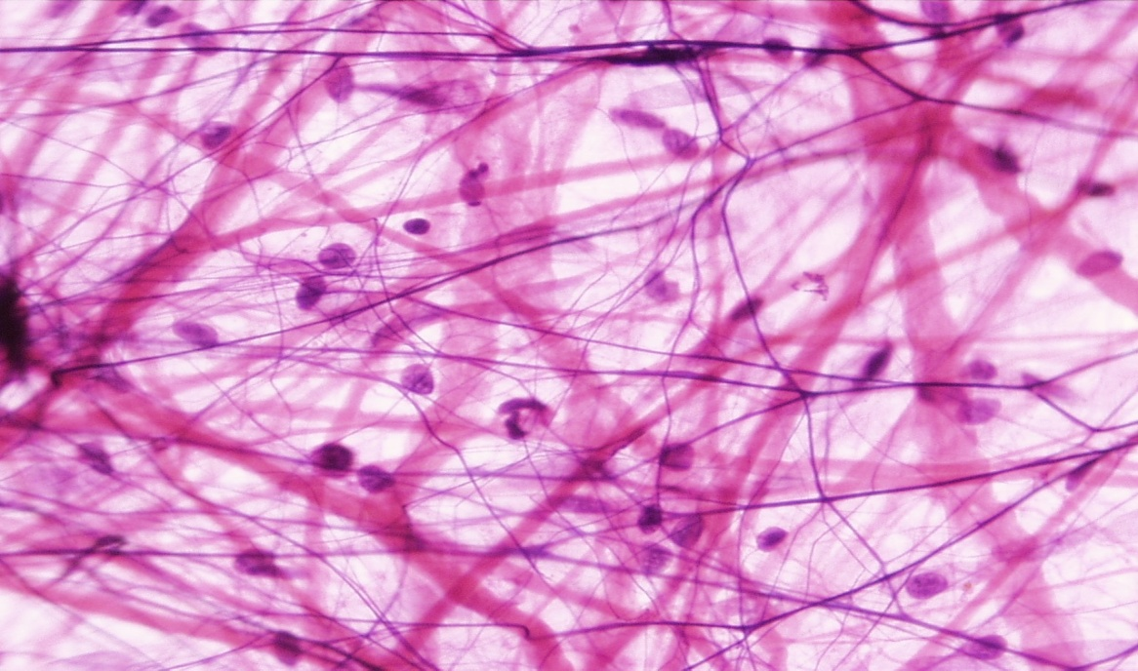
Dream team Questions on CT
- What are the 3 types of fibers?
- What are the 4 major types of CT?
- What are characteristics of CT?
- What are the Functions of CT?
Figure 1
- What are the differences between CT and epithelium?
- What are the 3 types of CT proper?
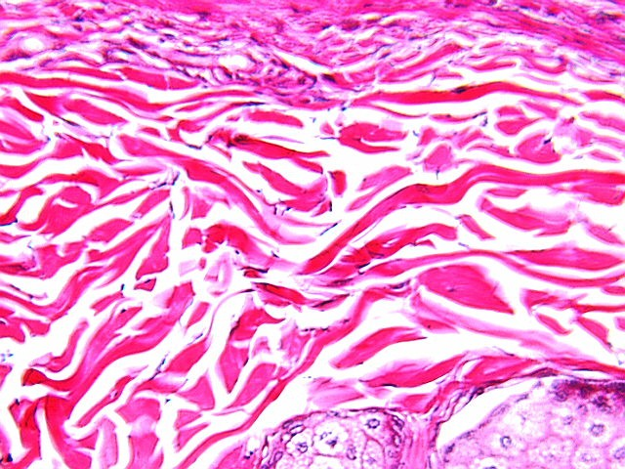
- Where does the CT derive from?
- What types of cells are associated with CT?
- What type of CT is in figure 1?
- What type of CT is in figure 2?

Figure 2
10 Questions on Epithelium
1.) What is the most common type of Epithelium?
2.) What epithelium is found in the bladder?
3.) What epithelium is found on the bottom of the feet?
4.) What is the difference between stratified and simple epithelium?
5.) What is the difference between stratified columnar and pseudo-stratified columnar epithelium?
6.) What is the advantage to transitional epithelium found in the bladder?
7.) What does keratinized mean?
8.) What are three functions of epithelium?
9.) Where is pseudo-stratified columnar located
10.) What is endothelium?
10 questions on girdles and limbs
- What are the 3 fused bones of the hip?
- What are 3 differences between male and female hip?
- What are 3 similarities between male and female hip?
- What 1 function of the hips?
- What is the tailbone called?
- What are the bones of the lower limb?
- What does the head of the humerus connect to?
- What does the Clavicle connect to?
- How many Metatarsals, Tarsals, and Phalanges
- How many bones in the lower limb
10 membrane questions
- What is a membrane?
- What are the 3 main membrane names?
- What epithelium makes up the cutaneous membrane?
- What is different/unique about the cutaneous membrane compared to the other membranes?
- What is the function of a mucous membrane line?
- Does the mucous membrane have to secrete mucous?
- What organs does a mucous membrane line?
- What is and where can you find a serous membrane?
- What is pericarditis?
- What does the pleura line do? The pericardium?
Skull questions
- What is the name of the bone that makes up your forehead?
- What is the name of the hole in your chin?
- How many facial bones are there?
- How many cranial bones are there?
- What is the total number of bones in the skull?
- What is the thin bone in the nasal region of the skull?
- What is the line between the frontal and coronal bones called?
- Where does the mandibular condyle attach?
- What is the pointy bone that’s inferior the the external acoustic meatus?
- Which bone makes up your cheek bone?

Vertebrae Questions
- What tyoe of vertebrae contains transverse processes?
- Which vetebrae is massive and weight sustaning?
- Which vertebrae supports the head?
- Which Vertebrae has circular verterbral formen?
- Which part of thespine has 12 vertebrae?
- Which part of thespine has 7 vertebrae?
- Which part of thespine has 5 vertebrae?
- Where do the ribs attach to the vertebrae?
- What are the three abnormal spine curvatures?
- Describe the three groups of the vertebrae?

