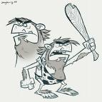
Early Man
VOCAB #1 - Paleolithic People
I CAN… | I CAN explain why Paleolithic people migrated and did not stay in one place.
Archaeologist | A __________ who studies ___________ and remains of past people
Prehistory | The time when people first appeared on Earth,  before ___________ developed, about ________ years ago.
Civilization | When people began to ____________ culturally and _______________________.
Migrate | ___________ from place to place, usually during different seasons.
Land Bridge | A _______ _______ of land connecting two _________ pieces of land.  *The sea level fell and land appeared allowing people to migrate from Africa to Asia, Europe, and eventually the Americas.
Paleolithic Age | The first age when people lived. They moved with ___________ and were ___________________________.
Hunting and Gathering | Finding food by ___________ animals (_____) and __________ berries, fruits, and nuts (_______)
Bands | About _______________ people living together and searching for food (in one big group). Like a large family.
Neanderthals: | First people on Earth:  homo habilis - Man who ______________________________  homo erectus - Man who ______________________________  homo sapiens - Man who ______________________________

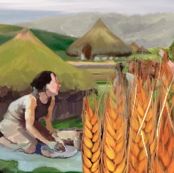
Early Man
VOCAB #2 - Neolithic People
I CAN… | I CAN identify factors that allowed Neolithic people to stay in one place AND how these factors allowed humans to develop into more complex societies.
Neolithic Age | Time when people ___________________  (no longer hunters and gatherers)
Domestication | The process of _____________ an animal and keeping it as a pet or on a farm.
Population | All the ______________ living in a particular town, area, or country.
Agriculture | The science or practice of ______________  (Neolithic people introduced agriculture to us!)
Herding | _____________ _____________ in fenced enclosures
Specialization | The process of _________________________ on, and becoming an _____________ in, a particular subject or skill.

