Math 4 Name_______________________________

**3-1 Introduction to Rational Functions** Date________

*In this activity, you are working towards the following learning goals:*

* *I can interpret expressions for rules of rational functions that model problem conditions*

A typical coffee mug will hold around 300 cubic centimeters (cc) of coffee. This will leave space for cream. The coffee situation is this: what percent of a coffee and cream mixture is coffee? This is sometimes called the strength of the coffee. Many restaurants provide cream in small containers. Since the containers are usually not full, an estimation of the amount of cream in one container is 6 cc. Suppose you put one container of cream in your coffee, the strength has changed from 100% to something lower. The strength can be found by dividing the amount of coffee by the amount of mixture; thus the mixture now has a strength of , or 98% coffee. If you add two containers of cream, the strength has changed to , or 96.2% coffee.

1. Write a formula that will give you the strength of the coffee for *x* number of creams.



2. If you have not done so in question (1), simplify your formula by factoring out a common term.



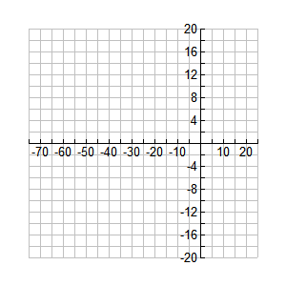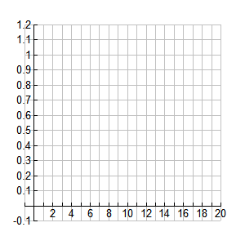3. Graph your function from question (2) on your calculator. Sketch it using both windows shown below. **On calculator: scratchpad button to get to graph 🡪 Menu-4-1 to change window.**

4. Which graph is the more practical graph, given the context of the problem? Explain.

5. What happens to the function when . Explain both in terms of the graph and the equation.

The function is a **rational function**. A rational function is the quotient of polynomials. The parent

function for all rational functions is . In your previous math courses, you have learned that

division by zero is undefined. This means in the function , the value of *x* cannot be zero. If the

domain of the function contains 0, the value of the function is undefined at that value. The definition of

a function requires that the elements of the domain must be real numbers AND the corresponding values

of the range must also be real numbers; thus .

In the rational function , the behavior of the function as values of *x* get closer and closer to 0 proves to

be one of the interesting characteristics of the function. To investigate the behavior of the parent

rational function , a numeric representation is developed below.

|  |  |  |  |  |  |  |  |  |  |  |  |  |  |  |  |
| --- | --- | --- | --- | --- | --- | --- | --- | --- | --- | --- | --- | --- | --- | --- | --- |
|  | -500 | -10 | -5 | -1 | -0.1 | -0.01 | -0.001 | 0.001 | 0.01 | 0.1 | 1 | 2 | 5 | 10 | 500 |
|  | -0 | -0.1 | -0.2 | -1 | -10 | -100 | -1000 | 1000 | 100 | 10 | 1 | 0.5 | 0.2 | 0.1 | 0.002 |

6. What is happening to the values in the above table as *x* approaches 0 *from the left*? That is:



7. What is happening to the values in the above table as *x* approaches 0 *from the right*? That is:



8. Sketch a graph of . Explain how your answers to questions (6) and (7) show up in the graph of .

9. Consider the function 

a. State the **domain** of *C .*

b. Graph the function on your screen using the window:

XMin: -200, XMax: 300, XScale: 30, YMin: -600, YMax: 600, Yscale: 100

Sketch your graph below.

c.  d. 

e. Write the equation of the vertical asymptote.

Now let's study this function's **application**.

is the cost (in thousands of dollars) to remove *x* percent of a city's pollutants discharged into a lake.



h. Now state the domain that fits the above practical application.

i. Find and **interpret in the context of the problem**.

j. Interpret the result from part (c) in the context of the problem.

10.

When the crow picks up and drops the Whelk, the shell does not always break on the first drop. Therefore, the crow must balance the amount of effort it takes to fly into the air with the Whelk with the likelihood that the Whelk shell will break when dropped from a certain height. The average work required (in joules) for the crow to break the Whelk shell at height *h* is:



a. What is the domain of *W*?

b. Write the equation of the vertical asymptote of *W*.

c. Graph *W* on your calculator and sketch a graph on the axis below. Label the vertical asymptote.

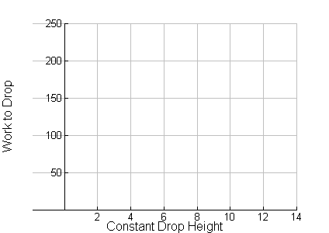

d. Find the limit of *W* as *x* approaches the vertical asymptote from the right. Write your answer in limit notation.

e. Interpret the limit and vertical asymptote in the context of the problem.

f. Use your calculator to find the optimal drop height for the crow. How does that compare with the actual drop height the crows use?