Math 1 Name_______________________________

**3-2 Homework**  Date________

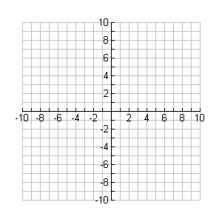Solve the systems in Numbers 1-3 by graphing. Write your answer as an ordered pair.

1. 

2. 

3. 

Solve the systems in Numbers 4-6 using the substitution method. Write your answer as an ordered pair.

4. 

5. 

6. 