Math 4 Name_______________________________

**3-2 Limits** Date________

**Example 1**

Suppose you had 24 inches of wire and wanted to make the biggest rectangle possible. How could you determine the dimensions that would result in the maximum area? Read the solution below.

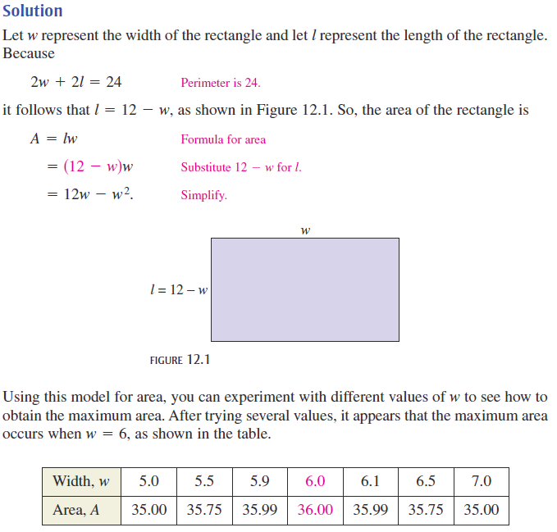

We can say that **the limit of *A* as *w* approaches 6 is 36**, denoted by  This just means that as the width of the rectangle gets closer and closer to 6 inches, the area gets closer and closer to 36 in2.

**Practice 1**

Fill out the table below to help you determine the limit of as *x* approaches 2. Use proper limit notation to write your answer below the table. Round to the nearest thousandth if necessary.

|  |  |  |  |  |  |  |  |
| --- | --- | --- | --- | --- | --- | --- | --- |
| *x* | 1.9 | 1.99 | 1.999 | 2 | 2.001 | 2.01 | 2.1 |
| *f*(*x*) |  |  |  |  |  |  |  |

Solution:

In both problems on the first page, the limit of the function was the same whether *x* approached from the right or left. For example, in Practice 1, as you start at *x* = 1.9 and increase to 2, you end up with the same *f*(*x*) value as when you start at *x* = 2.1 and decrease to 2. This is just one of many results you may encounter with limits. Example 2 illustrates another.

**Example 2**

1. At this point in your mathematical careers, I’m sure you’ve come to know and love functions like  What happens to this function when *x* = 2?

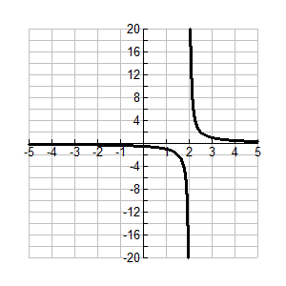

1. The function is graphed to the right. What does the limit of *j*(*x*) appear to be as *x* approaches 2 from the left side of the graph? Notice the appropriate limit notation used below.



The indicates the direction *x* is approaching 2 (from the left).

1. Now determine the limit as *x* approaches 2 from the right. Notice again the limit notation used below.



***When your limit approaches infinity or negative infinity, this is an indication that your graph has a **vertical asymptote** at that point. We will discuss these in more detail in the near future.

**Practice 2**

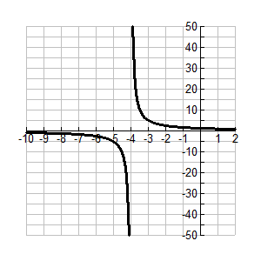Determine the limit of as *x* approaches 5 from the left and from the right. Use the proper notation in your answers.

**Example 3**

We often want to know the **end behavior** of a graph, that is, when *x* gets extremely large or small. This is simply finding the limit of the function as *x* approaches  or 

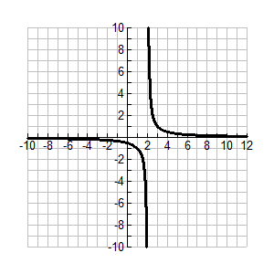Let’s take a look again at  Its graph is to the right.

Determine the end behavior of the graph by filling out the tables below (round to four numbers after the decimal), then write the limits as *x* approaches  and 

|  |  |
| --- | --- |
| *x* | *j*(*x*) |
| 0 |  |
| -100 |  |
| -200 |  |
| -300 |  |
| -400 |  |
| -500 |  |

|  |  |
| --- | --- |
| *x* | *j*(*x*) |
| 0 |  |
| 100 |  |
| 200 |  |
| 300 |  |
| 400 |  |
| 500 |  |

 

***We say that *j*(*x*) has a **horizontal asymptote** at *y* = 0. This is also a topic we’ll be revisiting soon.

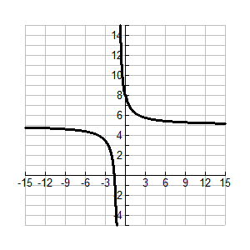**Practice 3**

Determine the end behavior for  Use proper limit notation in your answer.