Math 4 Name_______________________________

**3-2 Practice** Date________

Use limit notation to describe the behavior of the function at the point(s) of discontinuity.

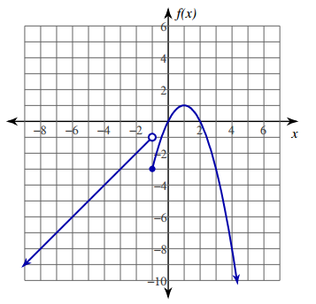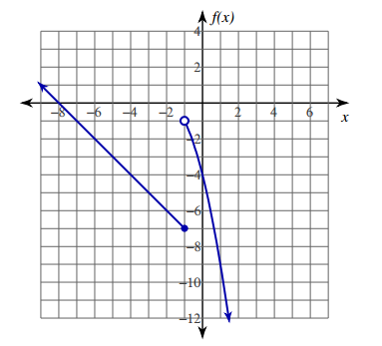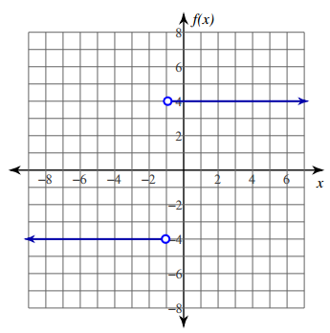

1. 2. 3.

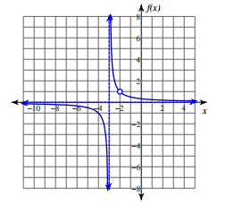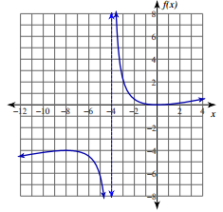

4. 5.

Use limit notation to describe the behavior of the function at *x* = -3.

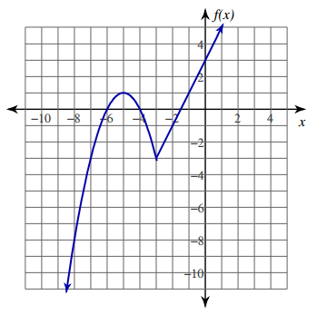

6.

Use limit notation to describe the end behavior of the following functions.



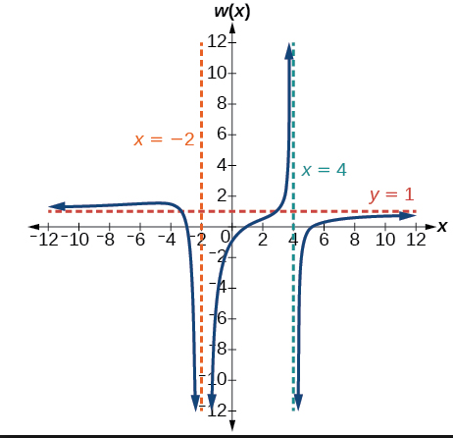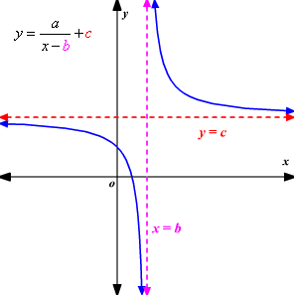7. 8. 9.

10. Sketch the graph of a function with the following characteristics:



