Math 1 Name ________________________

**3-2 Solving Systems of Equations by Graphing and Substitution** Date________

Learning Goals:

* *I can explain why and identify some systems of equations that have no solutions and some that have infinitely many solutions.*
* *I can solve systems of equations graphically, using elimination and substitution.*
* *I can identify the solution of a system of equations as an intersection point on a graph.*
* *I can write, solve and graph the system of equations and/or inequalities that best models the real-world problem.*
* *I can infer that since $y=f\left(x\right)$ and $y=g\left(x\right), f\left(x\right)=g\left(x\right)$ by the substitution property.*

Graph the following systems of equations and estimate the point of intersection.

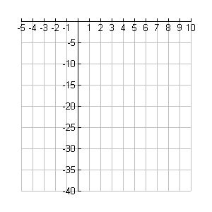 2. 

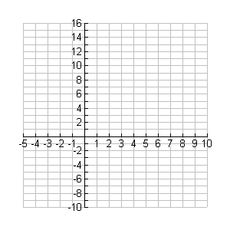

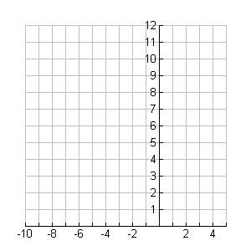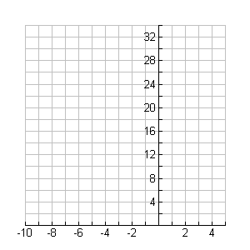 

Solve the following systems of equations using substitution.

5.  6. 

7.  8. 

9.  10. 

11.  12. 