Math 4 Name_______________________________

**3-3 Properties of Rational Functions Introduction** Date________

From your previous work in mathematics, answer the following question:

1. If you are given a function, how do you find the following:

a. *x*-intercepts -

b. *y*-intercept -

c. asymptotes - Vertical:

Horizontal:

Oblique:

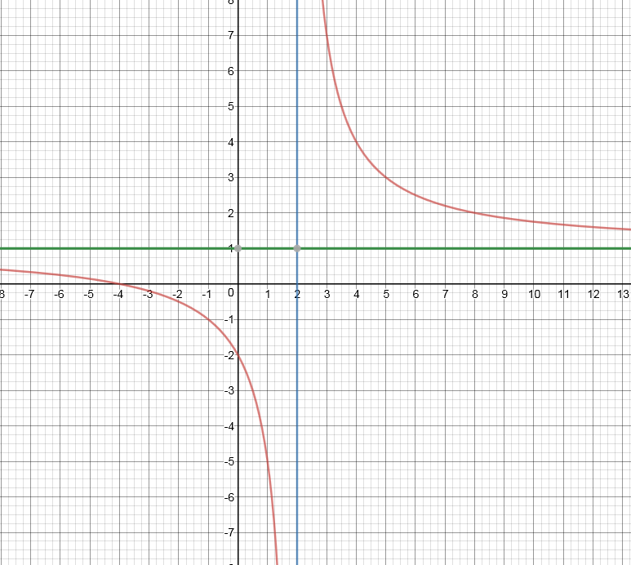

2. If you are given a function, how do you find the following:

a. *x*-intercepts -

b. *y*-intercept -

c. asymptotes - Vertical:

Horizontal:

Oblique:



