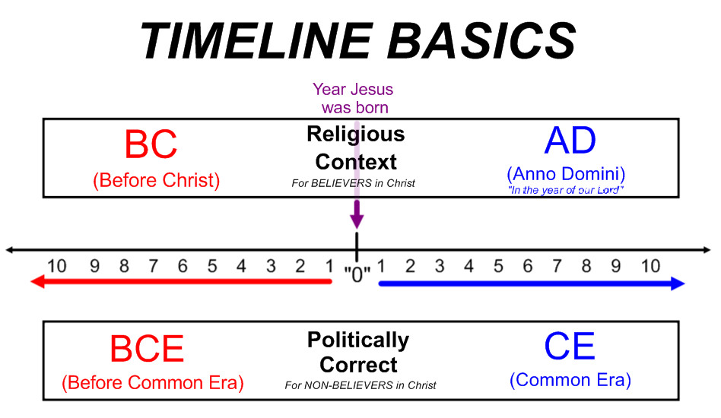
ARRANGING DATES ON A TIMELINE
- First, look at all of the dates and separate them by BC/AD or BCE/CE
*Remember … if dates don’t have any indicator, they are A.D.
- Then, arrange each set of dates in order:
  - BC: Larger numbers are farthest away from the birth of Christ, to the left “0” (they “count down” to his birth)
  - AD: Smaller numbers are closest to the birth of Christ (they “count up” from his birth) For example, the year 2015 is….two thousand & fifteen years after the birth of Christ
- Look at the dates already on the timeline and decide where your dates belong.

STEPS IN CREATING A TIMELINE
- Arrange the numbers in chronological order from the oldest to the most recent. Round the least and greatest numbers to easy whole numbers ending in zero
Oldest Newest
- Choose one:
  - If the numbers are from the same era, subtract to get the total years.
  - If the numbers are from both the B.C. and A.D. eras, add the two numbers to get the total years.
- Decide how many intervals (parts) the timeline should have by dividing the total years (in step 3) by 4, 5, 6, 7, 8, 9, or 10 parts. You can’t have a remainder! Use your calculator if necessary.
- Use a ruler to make neat, equal intervals.

