Math 4 Name_______________________________

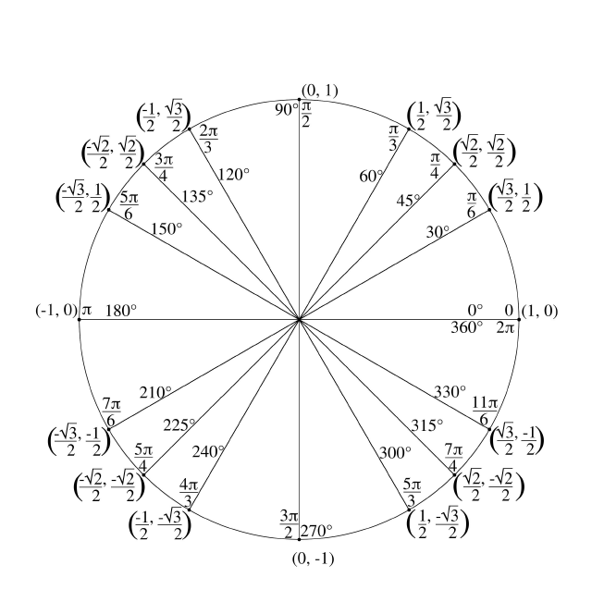**4-1 Trigonometry Review**  Date________

To be successful in this unit, it is ABSOLUTELY NECESSARY that you can find the unit circle exact values of sine, cosine, and tangent. See the unit circle below:

* The equation of the unit circle is , meaning that the radius of the circle is ___ and the center is ______
* The coordinates of a point on the circle that is located at the intersection of the circle and angle, made with the ***x-axis*** and the terminal side of the angle is 
* . Also, is the slope of the terminal side of angle

You will need to have a working knowledge of the values on this unit circle – the values of the coordinates and the values of the angles that lead to the coordinates. Notice I said *working knowledge*, not that you have to have the values memorized. If you *understand* the unit circle, you do not need to memorize all the values. **Take notes below as we develop what that means:**

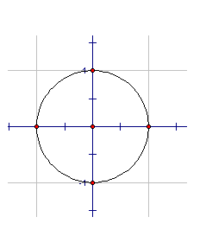**Find the values of the following expressions. Locate the given angle in each circle. Do NOT use a calculator. Your answers should be exact values. The radius of each circle is 1.**

1.  2. 



3.  4. 



5.  6. 



7.  8. 

**Solve the following equations using the unit circle. Give all solutions found in one rotation around the unit circle (called *primary value solutions*) Give your answer in radians.**

9.  10. 

11.  12. 

13.  14. 

15. 