Math 4 Name ______________________________

**4-3 Practice** Date________

Below are four different categories of problems. The first category is simply your basic identities, possibly rearranged. You NEED to be familiar with these identities and be able to manipulate them. After the identities , there are three sections of problems. The C problems are the easiest, and they get progressively more difficult as you make your way to the B and A sections. Make sure you try all the problems, even the hard ones!

*Do your work on another sheet of paper.*

**Identities**

1.  9. 

2.  10. 

3.  11. 

4.  12. 

5.  13. 

6.  14. 

7.  15. 

8. 

**“C” problems**

16. 22. 

17. 23. 

18.  24. 

19.  25. 

20.  26. 

21.  27. 

28.  31. 

29.  32. 

30.  33. 

**“B” problems**

34.  39. 

35.  40. 

36.  41. 

37.  42. 

38. 

**“A” problems**

43.  51. 

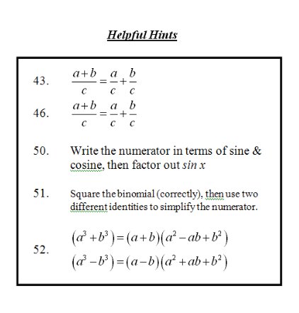44.  52. 

45. 

46. 

47. 

48. 

49. 

50. 