Math 1 Name_________________________

**4-4 Exponential Decay & Half-Life** Date________

* *I can define an exponential function.*
* *I can analyze the input and output values of a function based on a problem situation.*
* *I can convert a sequence into a recursive or explicit formula.*
* *I can correctly choose which formula best models a given situation.*
* *I can determine the practical domain and range in the context of a problem. And explain how they are related to the graph.*

1. Most Popular American sports involve balls of some sort. In designing those balls, one of the most important factors is the bounciness or elasticity of the ball. For example, if a new golf ball is dropped onto a hard surface, it should rebound to about of its drop height.

a. *Fill in the table below, then plot on the graph.*

|  |  |  |  |  |  |  |  |  |  |  |  |
| --- | --- | --- | --- | --- | --- | --- | --- | --- | --- | --- | --- |
| **Bounce #** | 0 | 1 | 2 | 3 | 4 | 5 | 6 | 7 | 8 | 9 | 10 |
| **Height (ft)** | 27 |  |  |  |  |  |  |  |  |  |  |

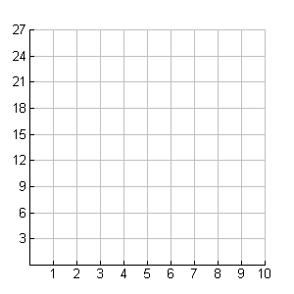a. How does the rebound height change from one bounce to the next? How is that pattern shown by the shape of the graph?

b. Write a recursive rule for the data.

c. Using function notation, write an explicit rule for the data.

Let *b* represent bounce # and *h* for bounce height.

d. If the ball was dropped from 15 feet instead of 27 feet…

i. How would the graph be different?

ii. How would the recursive rule be different?

iii. How would the explicit rule be different?

Definition of **half-life**:

__________________________________________________________________________________

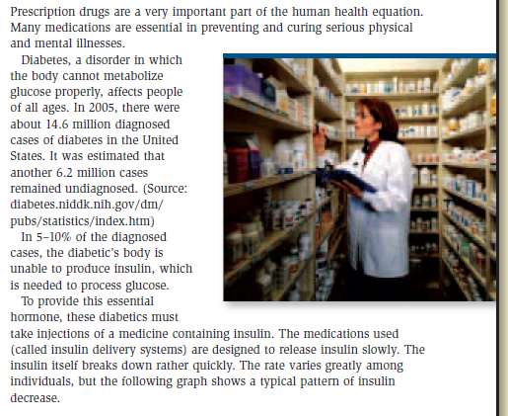

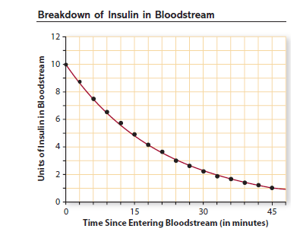

1. Medical scientists often are interested in the time it takes for a drug to be reduced to one half of the original does. They call this time the **half-life** of the drug.

The half-life of insulin appears to be _________.

I know that this is the half-life because. . .

2. The pattern of decay shown on this graph for insulin can be modeled well by the function , where *x* is the number of minutes since the insulin entered the bloodstream.

a. The number 10 in the function tells me:_____________________________________________

and the number 0.95 tells me _____________________________________________________.

b. The percent of insulin that is *used* each minute is _______________. I know this because. . .

3. Write a recursive rule that shows how the amount of insulin in the blood changes from one minute to the next.

4. Mathematicians have figured out ways to do calculations with fractional or decimal exponents so that the results fit into the pattern for whole number exponents. One of those methods is built into your graphing calculator. Enter the function in your calculator on the graph scratchpad. Hit CTRL+T to make a table to help you fill in the one below.

a. *(Round to the nearest tenth)*

|  |  |  |  |  |  |  |  |  |
| --- | --- | --- | --- | --- | --- | --- | --- | --- |
| **Elapsed Time (min)** | 0 | 1.5 | 4.5 | 7.5 | 10.5 | 13.5 | 16.5 | 19.5 |
| **Units Remaining** | 10 |  |  |  |  |  |  |  |
| **in blood** |  |  |  |  |  |  |  |  |

b. Do these points match with the graph of  on the previous page?

5. Solve the following equations using the graph of the function in your calculator. Round to the nearest tenth, and explain what your answer means.

a.  b. 

Solution: Solution:

Explanation: Explanation:

c.  d. 

Solution: Solution:

Explanation: Explanation:

6. Give the practical domain of the insulin problem.

7. Give the practical range of the insulin problem.

8. Use the function to estimate the half-life of insulin when….

a. The initial dose is 10 units, the half-life is approximately __________________________.

b. The initial dose is 15 units, the half-life is approximately __________________________.

c. The initial dose is 20 units, the half-life is approximately __________________________.

d. The initial dose is 25 units, the half-life is approximately __________________________.

e. The pattern is. . .

9. Car dealerships don’t like to keep used cars on their lot for long because most people that buy a new car trade in an old one. In order to keep their inventory of used cars low, they decrease the price of the used cars by 3% each month. Use a car that starts off at $12,500 for this problem.

1. What function will model the price of the car after any number of months (*m*)?
2. Write a recursive equation that will model this situation.
3. What will the price of the car be after 1 month?
4. What will the price of the car be after 1 year?

1. When will the car be worth at most $7000?
2. When will the price of the car be half of the original price?
3. What is a realistic domain and range for this situation?

Domain – Range –