The Sumerians created the first civilization that head a great influence on history. Later civilizations copied and improved many of the ideas and inventions that began in Sumer. As a result, Mesopotamia has been called the “cradle of civilization.” It was the beginning of organized human society.
Writing
Of all the contributions made by Sumerians to the world, writing is perhaps the most important. The writing system they developed was the earliest known system in the world. Writing was a way for Sumerians to keep records of their lives and their history. Writing was also a way to share information. They could pass on their ideas to later generations.
Sumerians created a way of writing called cuneiform. The cuneiform writing system was made up of about 1,200 different characters. Cuneiform was written by cutting wedge-shaped marks in to damp clay. Only a few people – mostly boys from wealthy families – learned how to read and write cuneiform. After years of training, some students became scribes, or official record keepers.
Wheel
The people of Mesopotamia also made many useful inventions. For example, the Sumerians were the first people to use the wheel. The first wheels were not used for transportation. Evidence shows they were created as potter's wheels around 3500 B.C. in Mesopotamia—300 years before someone figured out to use them for chariots. These were used for military use and wealthy Sumerians. The wheel was also used for carts that were pulled by donkeys.
Chariot
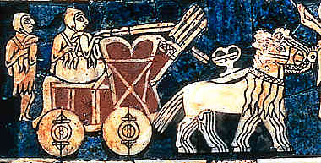
Humans learned to domesticate horses, bulls, and other animals that were useful for them. The chariot was not a sudden invention, but a slow improvement of the earliest carriage. The chariot was the first idea of personal transportation. It was used for warfare, most ancient sports, and a way to transport. The first chariot was made of light wood.
The first chariot was made around 3200 B.C. in Mesopotamia. The chariot was used in most every civilization until they created transportation with a motor. Chariots were also for the Royal families and higher class people.
Sailboat
Transportation by land was chaotic and took an enormous amount of time. Sumerians realized that transportation via sea would be a lot easier and more convenient. The first boat was invented and used as transportation in rivers, and needed to be navigated by humans. The sailboat was invented with a primitive (simple or basic) design, which ultimately helped the people with successful trade and business. It was initially used to cross the Tigris and Euphrates rivers for fishing and to explore other areas. The primitive (simple or basic) sailboat was square in shape and the sail was made of cloth. The direction of the sailboat couldn’t be changed. If the wind didn’t blow in the direction they wanted to go, they had to wait for a change the wind’s direction in their favor.
Mathematics
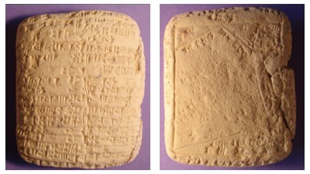
The Mesopotamians used a number system with the base 60 (like we use base 10). They divided time up by 60s including a 60 second minute and a 60-minute hour, which we still use today. They also divided up the circle into 360 degrees.
They had a wide knowledge of mathematics including addition, subtraction, multiplication, division, and fractions. This was important in keeping track of records as well as in some of their large building projects.
The Mesopotamians had formulas for figuring out the area for different geometric shapes like rectangles, circles, and triangles. They may have even discovered the number for pi in figuring the circumference of a circle.
Bricks
Sumerians used mud bricks to build homes, city walls, and even palaces. They would take clay from the riverbank and mix it with water and straw, and pour it into wooden molds in the shape of bricks, then let it dry in the sun. This is a very easy and cheap way for Sumerians to build.
If the bricks are put in fired or cooked in an oven before building with them, the bricks will last much longer. When Sumerians built important buildings that needed to stand for a long time, they fired the bricks first.
Plow
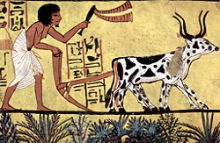
Humans learned to domesticate animals and use them in their daily life to make tasks easier. The earliest plow was made of wooden material and was heavy. The major problem with the plow was that the dirt would stick on the plow and needed to be removed manually. It also did not work in dense grass. The invention of the plow in Mesopotamia helped the hunter-gatherer groups to stay in the same place and to depend on agriculture for food, rather than hunting.
Plant and Harvest Food
Farmers used to grow wheat, barley, cucumbers and other different foods and vegetables. Tigris and the Euphrates rivers that surround Mesopotamia made farming a lot easier and more convenient. Farmers depended on the flooding of these rivers for water for their crops. The silt left behind from the flooding water made the soil fertile. Mesopotamians wrote handbooks that told how and when to plant crops.
Government
When large numbers of people live and work together, laws are needed to keep order. In large societies, such as the one in Sumer, the making of laws could be done only with a government. A government is an organized system that groups use to make laws and decisions.
Instead of Mesopotamia having one central government, each city-state had their own King with his own set of laws. This created many disputes over power, land, and resources.

Bronze Metal
Sumerians were the first to make bronze out of copper and tin. They used bronze to craft stronger tools, weapons, and jewelry. Bronze was used to make weapons more powerful. Sumerians would replace stone tips with bronze or sometimes iron. Spears were also tipped with bronze or iron spearheads. Bronze wasn’t the easiest resource to make, that’s why Mesopotamia barely used it. They used little tools made of bronze to make big tools.
Irrigation Systems
In places like Mesopotamia, it hardly rains at all. Farmers can't depend on the rainfall to water their crops. They have to find some way of getting water from the river to their fields. The way they get water from the river is called "irrigation." Mesopotamians learned to control the flow of water from the river and used it for irrigating crops.
During the main growing season, the flow of water was controlled. Each farmer was allowed a certain amount of water, which was taken from the canal into an irrigation ditch.
Ziggurats
The Sumerians built huge buildings of mud-brick which they called ziggurats. Each city-state would build its own ziggurat, partly to please the gods and partly to show how powerful the town was. On top of each ziggurat, there was a small temple for a Mesopotamian god.
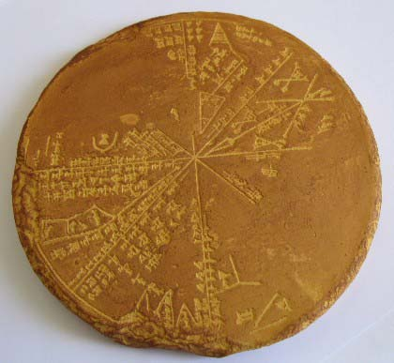
Calendar
Sumerians made a 12-month calendar based on the cycles of the moon. Citizens tracked 354 days each year. Occasionally, they added an additional month to the calendar to make up for the remaining 11.25 days in the year. This is an example of an early leap year. Unlike other calendars, the Sumerian calendar did not have a naming system for the months.

