Math 4 Name_______________________________

**5-1 Average Rate of Change**Date________

One of the most important topics in beginning Calculus is to understand average and instantaneous rate of change of a function. While these concepts might sound complicated, they are very similar to content you have learned in the past.

To analyze the **average rate of change** **, for a given time interval of a function , use the following formula:

**

The **is the same as what formula that you are familiar with?

Use the below problems to help you further understand 

When it comes to American median habits, the growth of blogs, emails, and music downloads has exceeded all expectations – though some old-media favorites have fared surprisingly well (data from *Newsweek* magazine, summer of 2010).

Based on the below data:

1.) Calculate ** for each media category. **Label each quantity with the correct units**.

2.) Indicate if the category is increasing, decreasing, or has no change.

|  |  |  |  |  |  |  |  |
| --- | --- | --- | --- | --- | --- | --- | --- |
| **iTUNES DOWNLOADS** | |  | **DAILY GOOGLE SEARCHES** | |  | **DAILY NEWSPAPERS** | |
| 2000 | 2010 |  | 2000 | 2010 |  | 2000 | 2010 |
| 0 | 10 billion |  | 100 million | 2 billion |  | 1,480 | 1,302 |

|  |  |  |  |  |  |  |  |
| --- | --- | --- | --- | --- | --- | --- | --- |
| **DAILY LETTERS MAILED** | |  | **REALITY TV SHOWS** | |  | **CD SALES REVENUE** | |
| 2000 | 2010 |  | 2000 | 2010 |  | 2000 | 2010 |
| 207.88 billion | 175.67 billion |  | 4 | 320 |  | $943 million | $427.9 million |

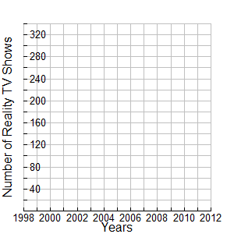3.) Graph the data for “Reality TV Shows” below. Graphically represent the ***.***

4.) Do you think this graphical representation of ******represents the typical growth of Reality TV

Shows?

5.) Explain what the  represents in terms of Reality TV Show growth.

6.) On the grid above, draw a graphical representation that you think represents the actual growth of Reality TV Shows.

**OVER 🡪**

Below is data for the average price of a movie ticket in North America over several years.

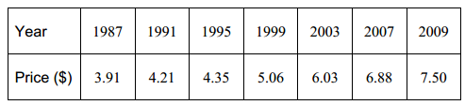

7.) Find the average rate of change from 1995 to 2003. Label your answer with the correct units.

8.) Find the average rate of change from 1999 to 2007. Label your answer with the correct units.

9.) Find the average rate of change from 2003 to 2007. Label your answer with the correct units.

10.) Do you think the function that models this data is linear? Explain

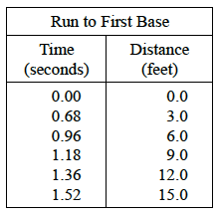Below is data for the time it takes a batter to run the first 15 feet to first base in a softball game.

11.) Find  for the interval of 0.00 to 0.68. Label your answer with the correct units.

12.) Find  for the interval of 0.68 to 0.96. Label your answer with the correct units.

13.) Find  for the interval of 1.36 to 1.52. Label your answer with the correct units.

14.) Do you think the function that models this data is linear? Explain.

15.) What is happening with the ******as time increases? What does that mean about the rate of increase of the function?

16.) Sketch what you think the shape of a graph of this data will look like. Check your answer by graphing the data on your calculator (enter the data into a “Lists and Spreadsheet” page and then graph it on a “Data and Statistics” page).

17.) Describe the motion of the runner over time for the first 15 feet of the run towards first base.