Math 1 Name_______________________________

**5-1 Transformations Practice** Date________

* *I can draw a transformation when given a geometric figure and a rotation, reflection or translation.*
* *I can predict and verify the sequence of transformations that will map a figure onto another.*
* *I can define rigid motion as reflections, rotations, translations, and combinations of these, all of which preserve distance and angle measure.*
* *I can determine the coordinates for the image of a figure when a transformation rule is applied to the preimage.*
* *I can draw transformations of reflections, rotations, translations, and combinations of these using graph paper and/or geometry software.*

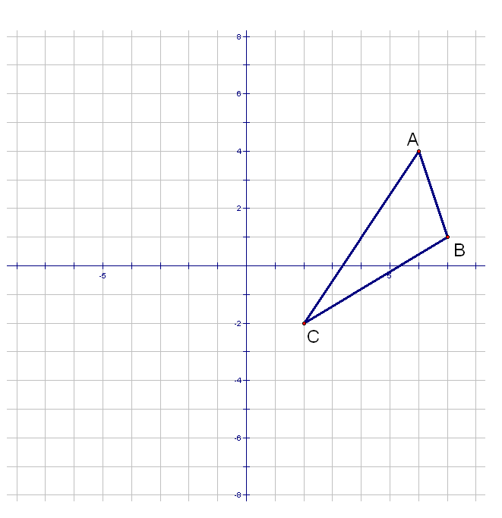1. List the vertices of the below figure:



2. Reflect triangle ABC over the *y*-axis below. Also list the coordinates of the image below.



3. Reflect triangle ABC over the line *y = x*. Also list the coordinates of the image below.



4. Reflect triangle ABC over the line *y =* 2. Also list the coordinates of the image below.

 

5. Reflect triangle ABC over the line *x =* 4. Also list the coordinates of the image below.



6. Rotate triangle ABC 90o counterclockwise. Also list the coordinates of the image below.



7. Rotate triangle ABC 270o counterclockwise. Also list the coordinates of the image below.



8. Translate triangle ABC -9 units horizontally and 2 units vertically. Also list the coordinates of the image below.



9. Translate triangle ABC -2 units horizontally and 3 units vertically. Also list the coordinates of the image below.



10. Find the coordinates of the vertices of the figure below:

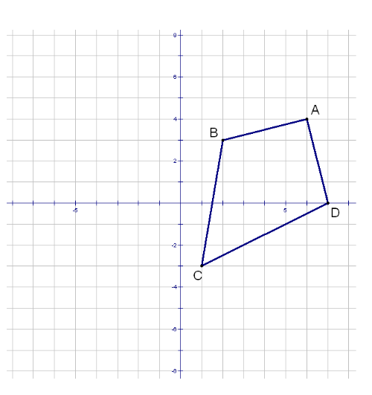 A = B = C = D =

11. Reflect the figure below over the *x*-axis.

12. Reflect the figure below over the line 

13. Reflect the figure below over the line 

14. Perform the following transformation on the figure below: 

What type of transformation did you just perform?

15. Perform the following transformation on the figure below: 

What type of transformation did you just perform?

16. Perform the following transformation on the figure below: 

What type of transformation did you just perform?

17. Perform the following transformation on the figure below: 

What type of transformation did you just perform?

List the transformation(s) and if possible, write a transformation rule for the figures below. The pre-image is the figure with the dashed lines; the image is the figure with the solid lines.

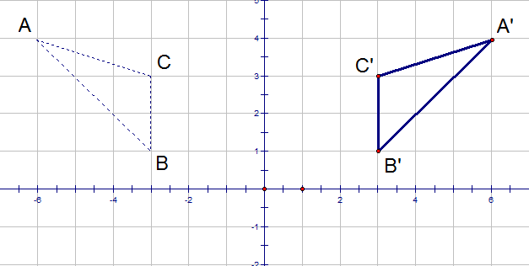18.

Transformation(s):

_______________________

_______________________

(*x*, *y*) 🡪

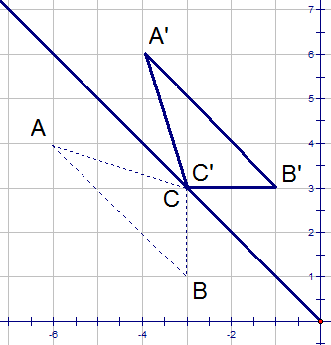19.

Transformation(s):

_______________________ _______________________

(*x*, *y*) 🡪

20. Transformation(s):

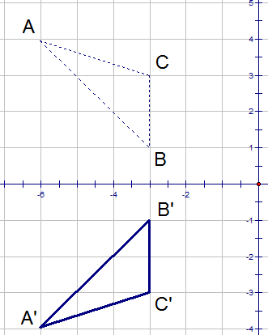 _______________________

_______________________

(*x*, *y*) 🡪

21.

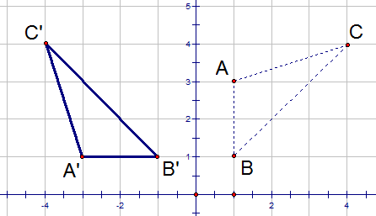

Transformation(s):

_______________________

_______________________

(*x*, *y*) 🡪

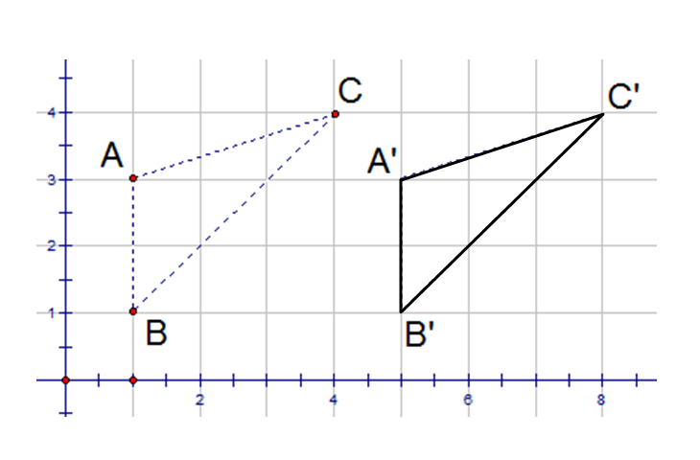

22.

Transformation(s):

_______________________

_______________________

(*x*, *y*) 🡪

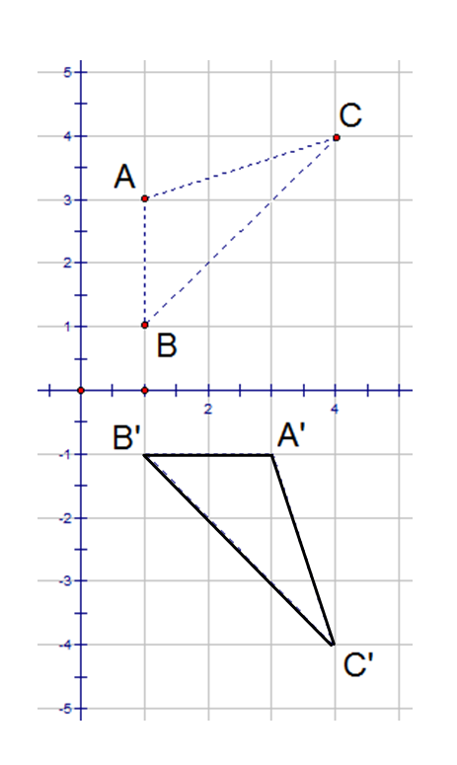23.

Transformation(s):

_______________________

_______________________

(*x*, *y*) 🡪

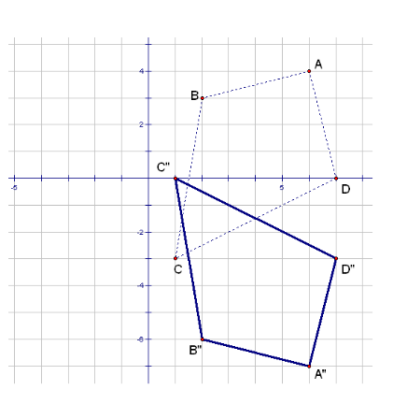

24.

Transformation(s):

_______________________

_______________________

(*x*, *y*) 🡪

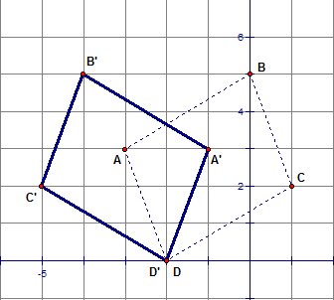25.

Transformation(s):

_______________________

_______________________

(*x*, *y*) 🡪

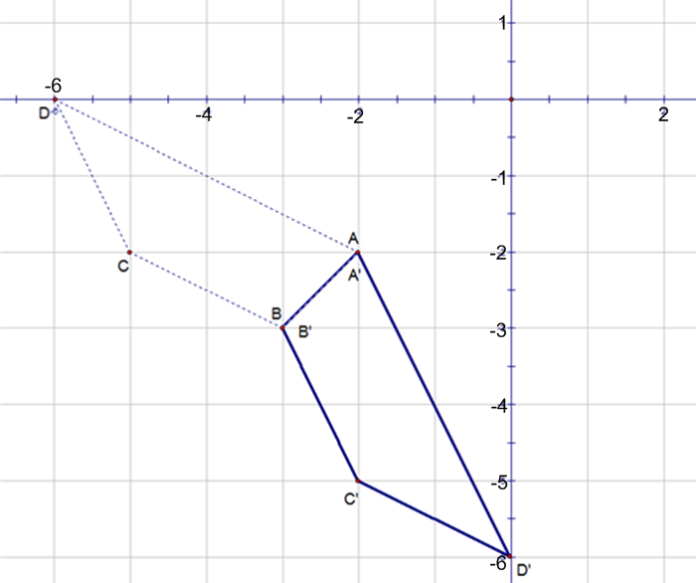

26. Transformation(s):

_______________________

_______________________

(*x*, *y*) 🡪

27. Transformation(s):

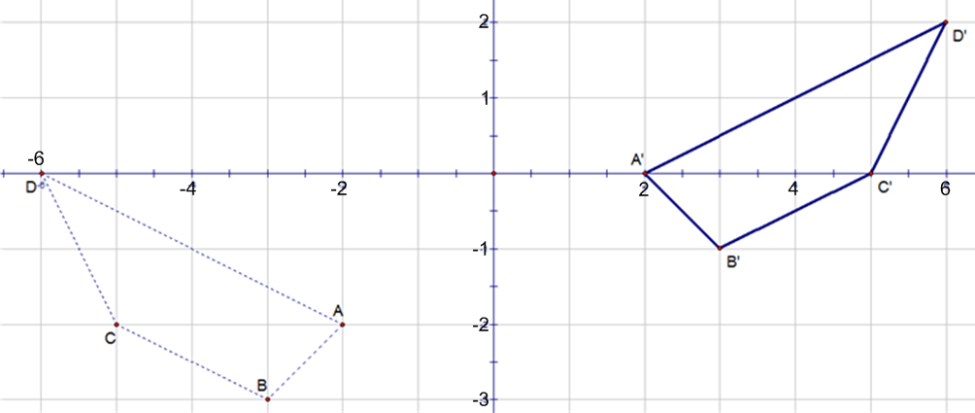

_______________________

_______________________

(*x*, *y*) 🡪